Adolph Reginald Grossman was born on 17 August 1913 to a Polish born father Maurice and London born mother Fanny Englander, whose parents originated from Krakow in Poland.
In 1911, Maurice was listed on the census as a buyer for a general export business. By 1921, Maurice was working as a woollen merchant from his premises at 184 Aldersgate Street, London. (now demolished and the Barbican now stands near the site).
By 1939, Adolph had met a Christian girl, Margaret King and in the 1939 Register he was living in the same house as Margaret and her parents Alexander and Ada at 27 Regal Way in Wembley. He is listed as working as an assistant works manager in a brass foundry and in October 1939 they married in Willesden.
Adolph enlisted into the South Wales Borderers on 2 November 1940 under a Regular Army Emergency Commission as a 2nd Lieutenant. He was an acting Captain at the time of his death in 1942.

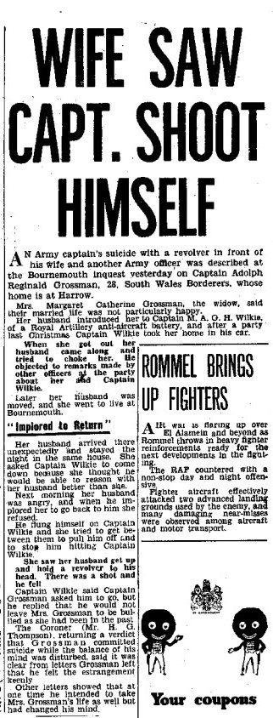
WIFE AND TWO OFFICERS ETERNAL TRIANGLE DRAMA AT BOURNEMOUTH. HUSBAND SHOOTS HIMSELF.
The wife of an Army captain gave evidence at Bournemouth inquest on Monday, that after a struggle in the sitting-room of the house where she was staying, her husband shot himself with a revolver in the presence of another officer and herself. The deceased was Capt. Adolph Reginald Grossman (28) and his home was stated to be at Harrow.
Mrs. Margaret Catherine Grossman said they were married in March 1939. and they were not particularly happy. Her husband introduced her to Capt. Wilkie, and on Christmas Day last year, there was an incident during a party, when some of the party had a lot of drink. Something was said about Capt. Wilkie and herself which she did not agree with but which her husband took very much to heart.
Capt. Wilkie took her home in his car, and she got out of the car her husband tried to choke her. She called to Capt. Wilkie and her husband let her go. Last May, continued Mrs Grossman, she came to Bournemouth to live with her sister. Her husband came to see her. He knew she was fond of Capt. Wilkie, and she asked him for divorce. There was no evidence to justify a divorce then and he asked her to return. She told him she could not do so. Her husband arrived unexpectedly at the house Boscombe, where she was staying, and she sent a telegram to Capt. Wilkie whom she thought could reason with her husband. When Capt. Wilkie arrived, her husband told him to go but he refused to leave her.
A little later she saw that her husband had a revolver his right hand. Then he suddenly flung himself at Capt. Wilkie and there was a struggle on the settee. Then he got up and held the revolver to his head. There was a shot and he fell. Captain Mark Wilkie also gave evidence.
P.S. Longman said he found Capt. Grossman lying on the floor with a revolver near his hand. It was fully loaded except for one cartridge which was discharged. Dr Scott said death was due to laceration of the brain from a gunshot wound.
The Coroner said a letter left by deceased confirmed the evidence given by Mrs Grossman and Capt. Wilkie. It dealt at great length with his affection for his wife and showed clearly that he felt the estrangement. and that he had apparently come to the conclusion that as she refused live with him any longer, he was not prepared to go on. In fact, said he intended to take his life for that reason. Other letters indicated that at one time the deceased intended to take his wife's life as well as his own but altered his mind later. It was not for him to judge whether the wife was right or wrong in deciding to leave her husband, but it was unfortunate that Mrs Grossman asked Capt. Wilkie to come to Bournemouth. The inevitable result was that there was a row and tempers were lost, and suddenly Capt. Grossman took his life.
A verdict of death from a self-inflicted wound at a time when the balance of deceased's mind was disturbed was returned.
Margaret went on to marry Mark Wilkie six months later in January 1943. Tragically 13 years later, Mark also shot himself dead in the bar at the Rose and Thistle pub in Rockbourne, Hampshire. He was 38 years old.
