Harold Devon Cross in error
Flying Officer Harold Alan Devon | War Casualty Details 2198552 | CWGC
Davis Devan, Harold’s grandfather, was born on 10 March 1865 in Warsaw, Poland. He married Annie in Poland in approximately 1888. Their first-born son Samuel was born in Poland in 1891. The family then travelled to England where their second son Jacob was born in Soho, London in 1898. He was followed by Solomon (Sydney) on 2 October 1899 and Nathan on 6 June 1900.
In 1901 the family were living at Broad Street Buildings in Westminster, London and Davis was working as a tailor.

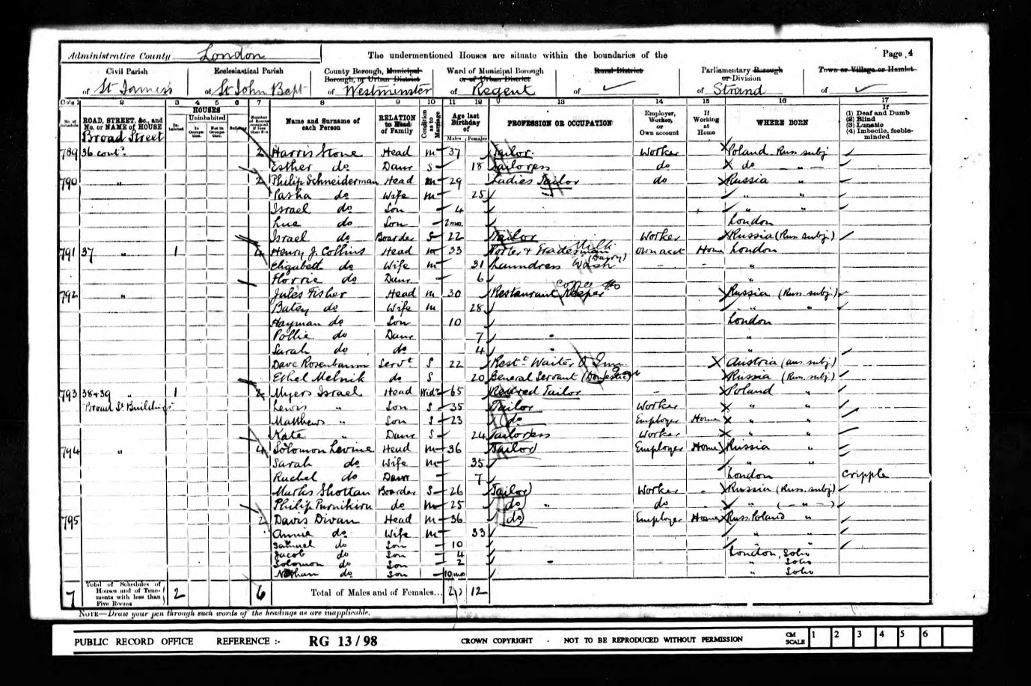
1901 Census
They had one more son, Simon who was born in 1903. In 1911, the family were living at 37 Marshall Street in Kensington and Davis, Samuel and Jacob were working as tailors.
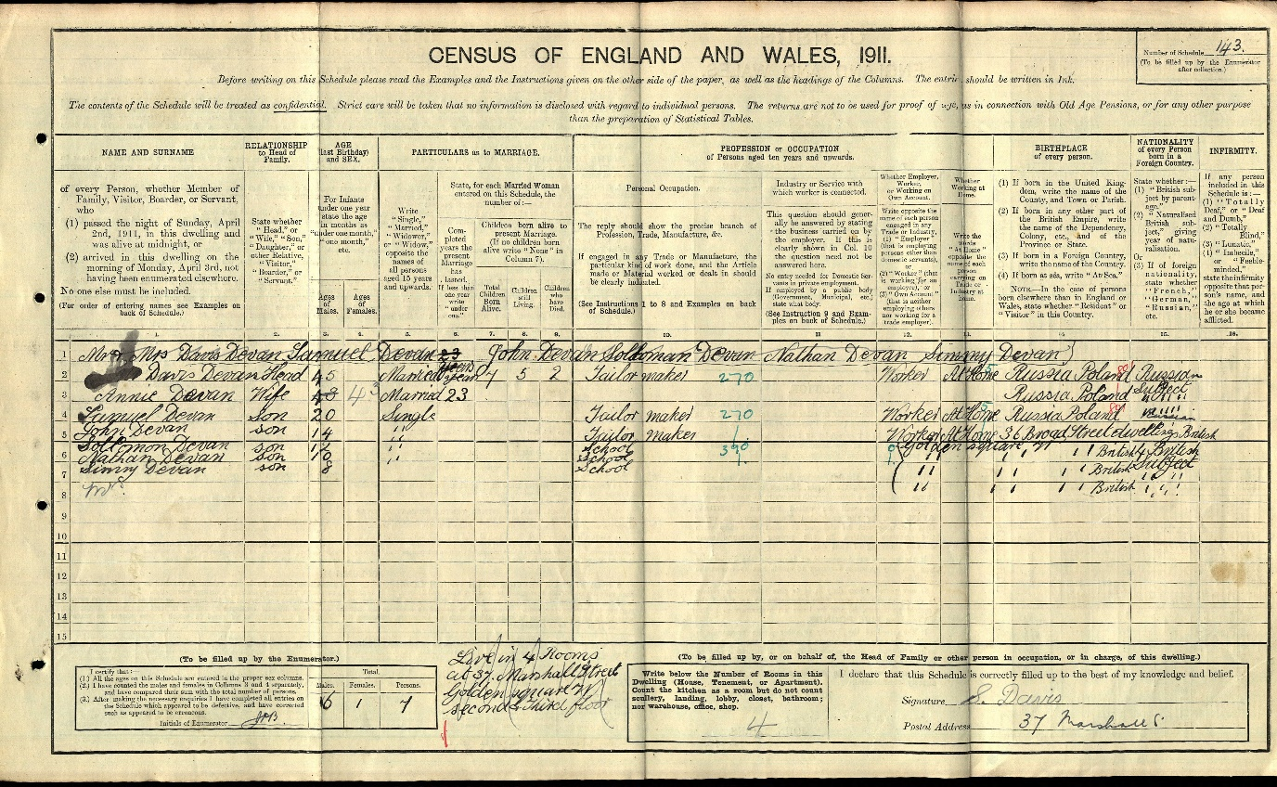
1911 Census
In 1921, the family were living at The Compasses Public House, 66 Cow Cross Street, where son Jack was listed as the licensed victualler.
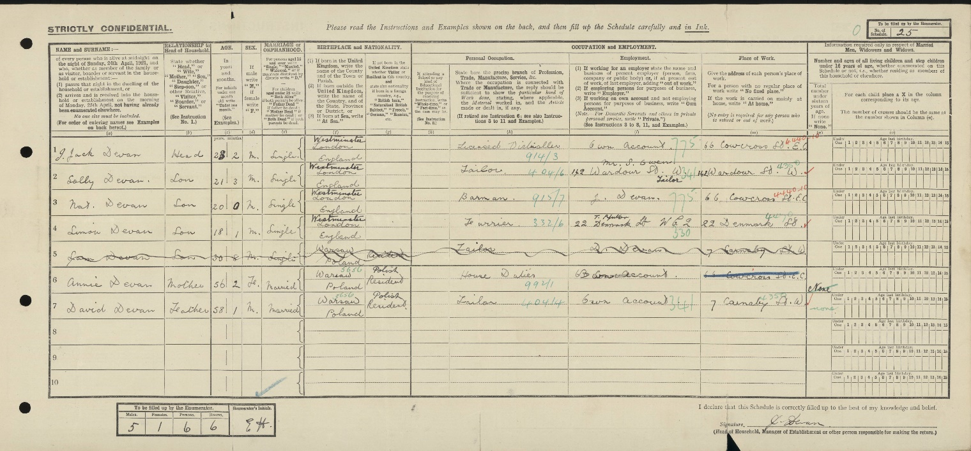
1921 Census
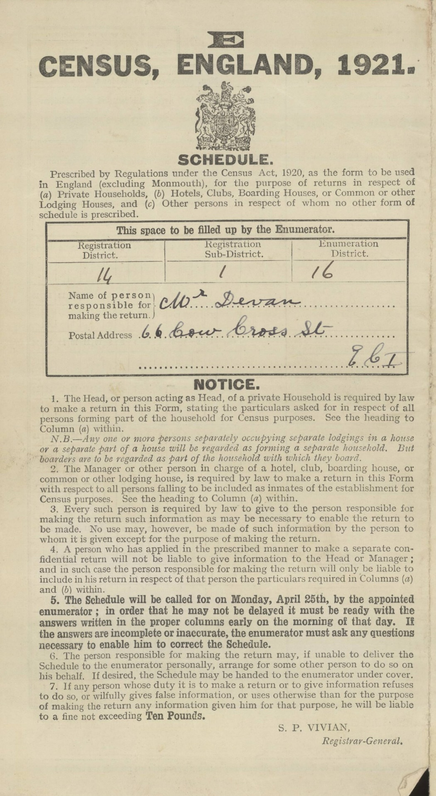
1921 address
On 5 September 1922, Solomon married Esther (called Hettie) Arbiter at the Philpott Street Synagogue, Mile End Old Town, London. Hettie was born on 11 February 1902 in Mile End Old Town to Isaac and Betsy Arbiter. Isaac was a hotel and restaurant proprietor at 164 Whitechapel Road, London.
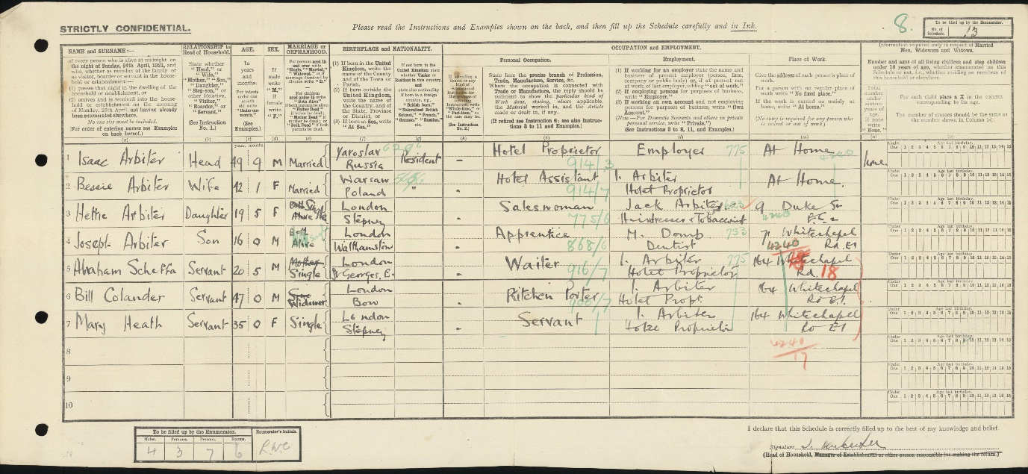
Arbiter family 1921
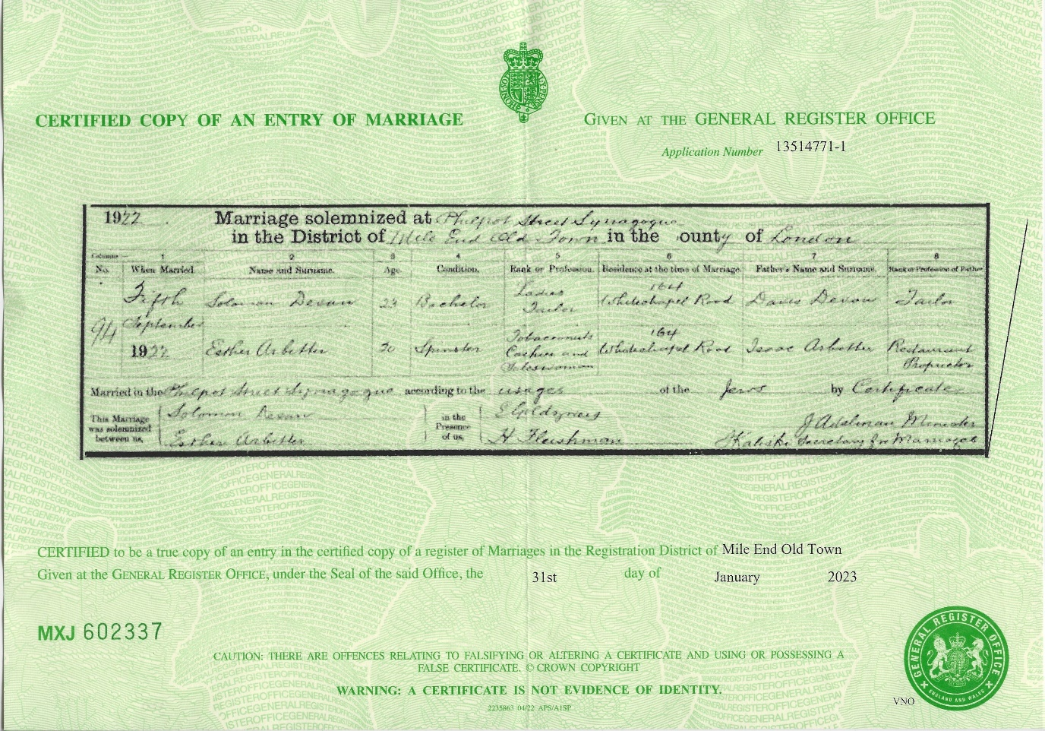
Solomon (Sidney) and Hettie’s Marriage Certificate.
Hyman Harold Devan was born on 29 June 1923 at 18 Honiton Road, Kilburn to Solomon (Sidney) Devan and Hetty (Esther) Arbiter.
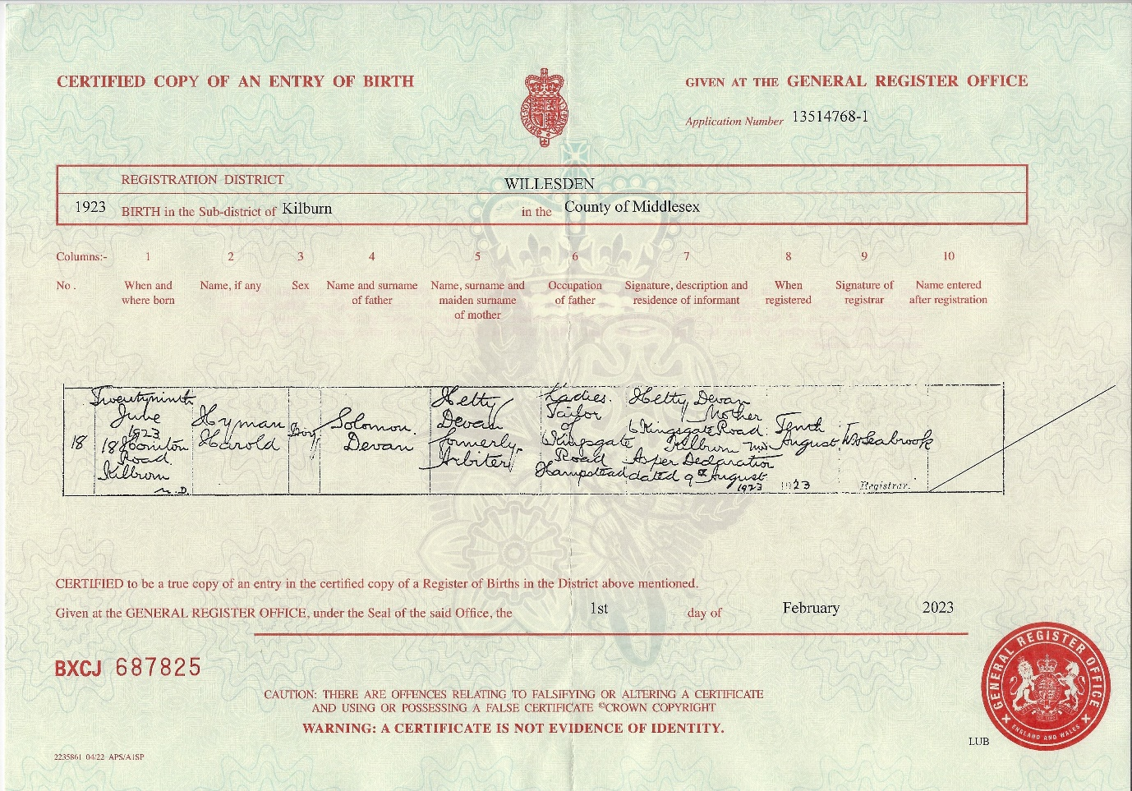
Hyman Harold’s birth certificate
In 1929, Sidney, Hettie and Harold were living at 155 Amhurst Road in Hackney, London. On 25 August 1929, Sidney returned from a trip to Montreal, Canada and the manifest lists him as a designer and shows his home address.
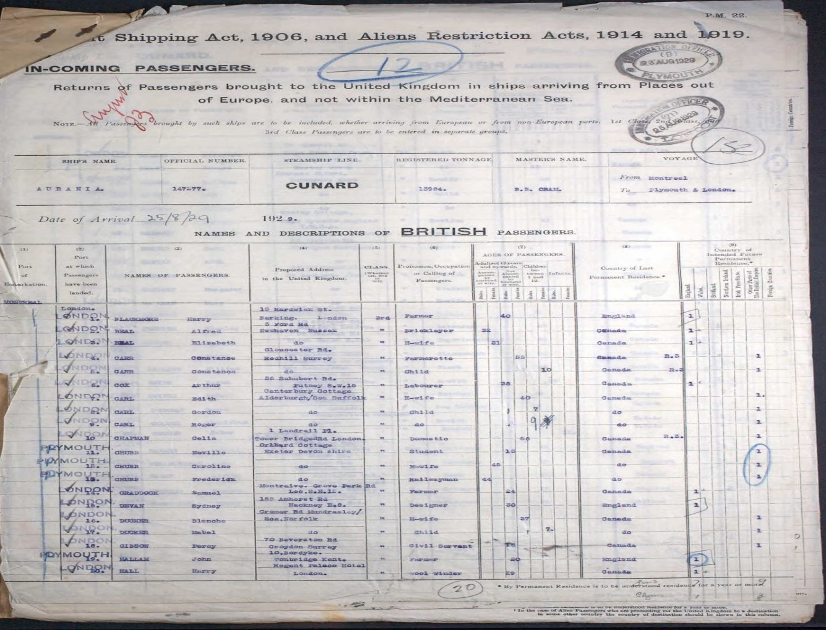
Sidney 1929 travel
By 1926, the Devan family changed their surname to Devon on the Electoral Registers. The 1926 Electoral Register shows them using the surname DEVON. Living at 155 Amhurst Road, the address they lived at until Sidney’s death in 1950.
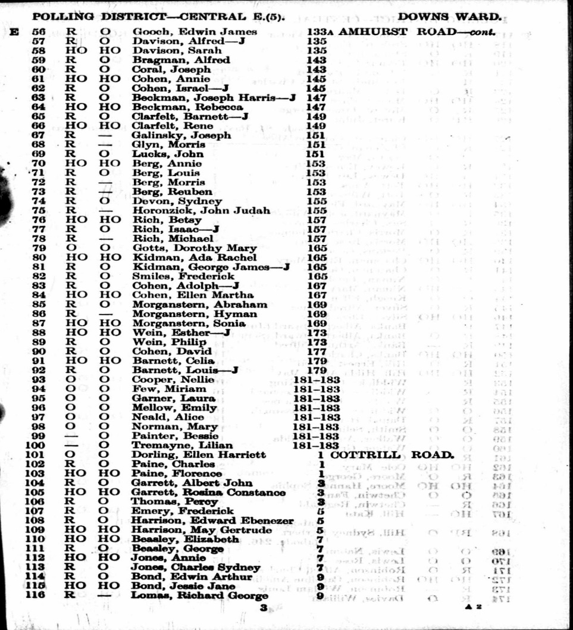1926 Register
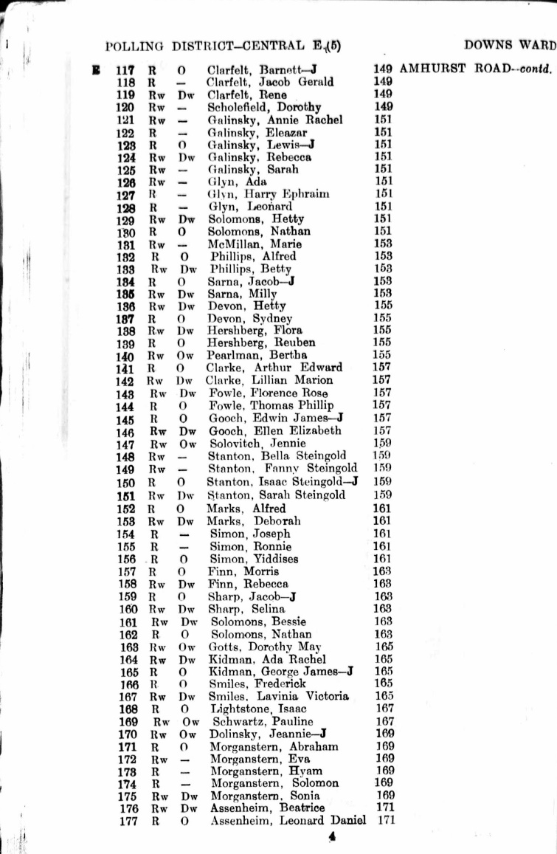1936 Electoral Register
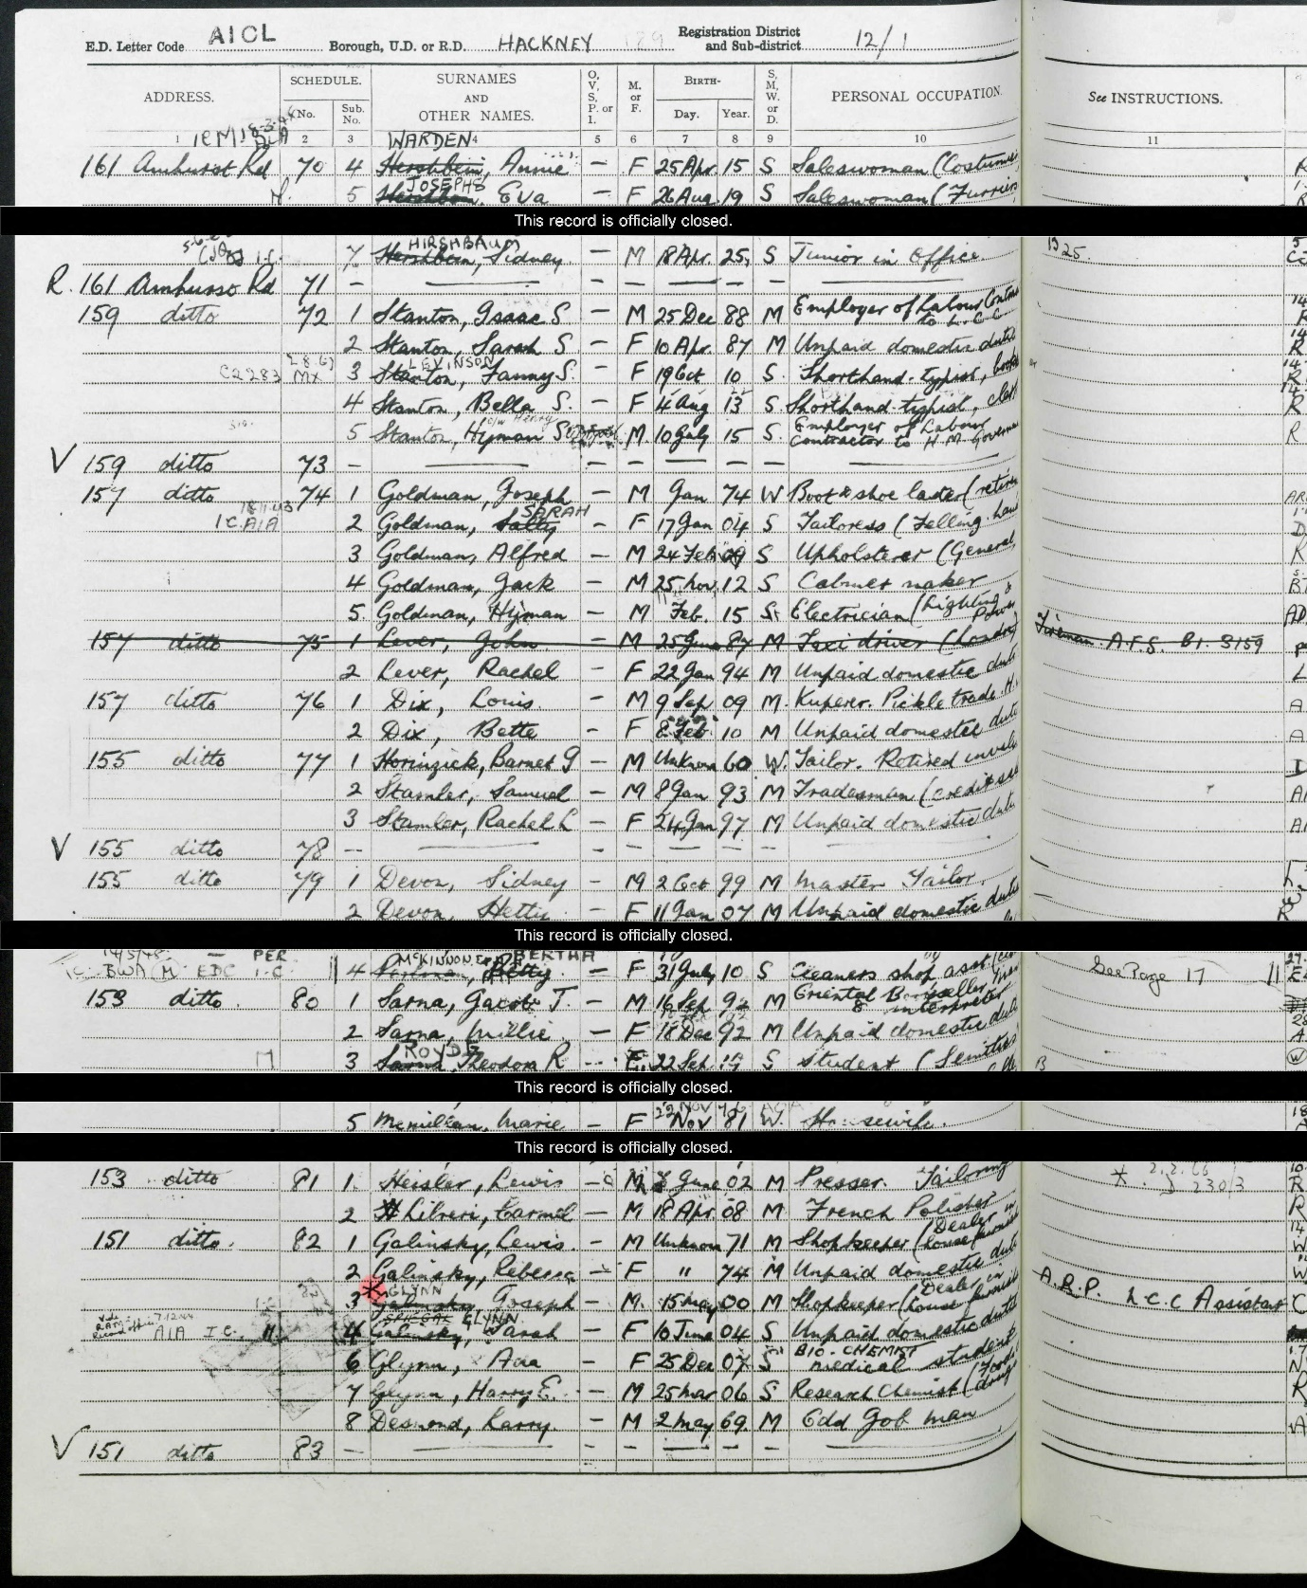
1939 Register
The 1939 Register shows Sidney and Hetty DEVON still living at 155 Amhurst Road in Hackney and Sidney is listed as a tailor. Harold worked as an insurance accountant.
Harold enlisted into the RAF in 1940 using the name Harold Alan Devon. After training he became a flying officer with the service number 136367.
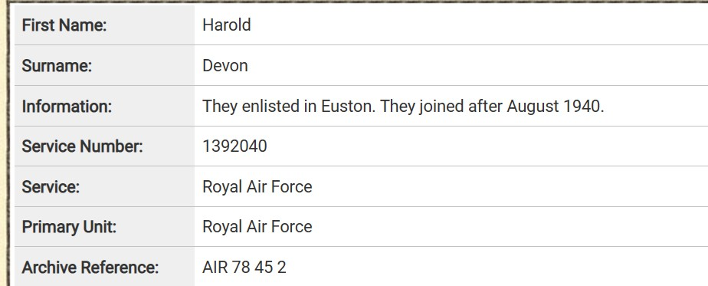
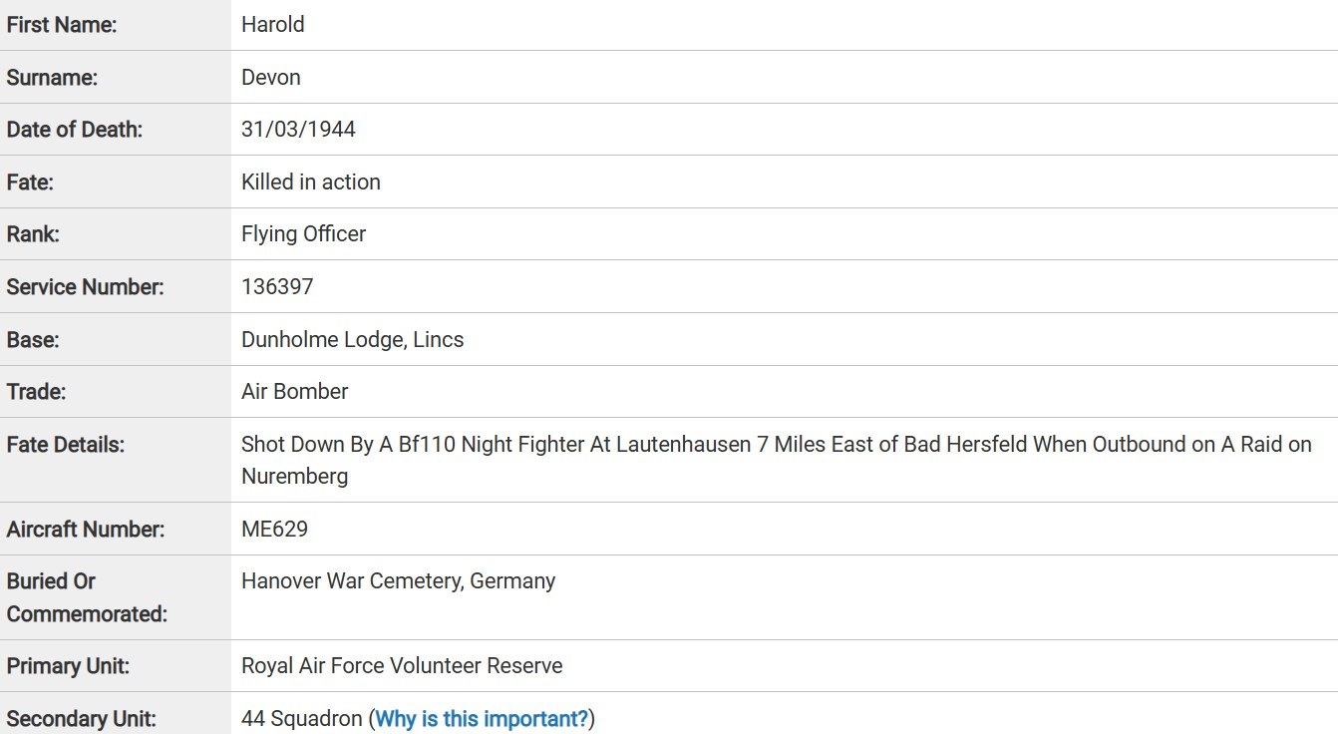
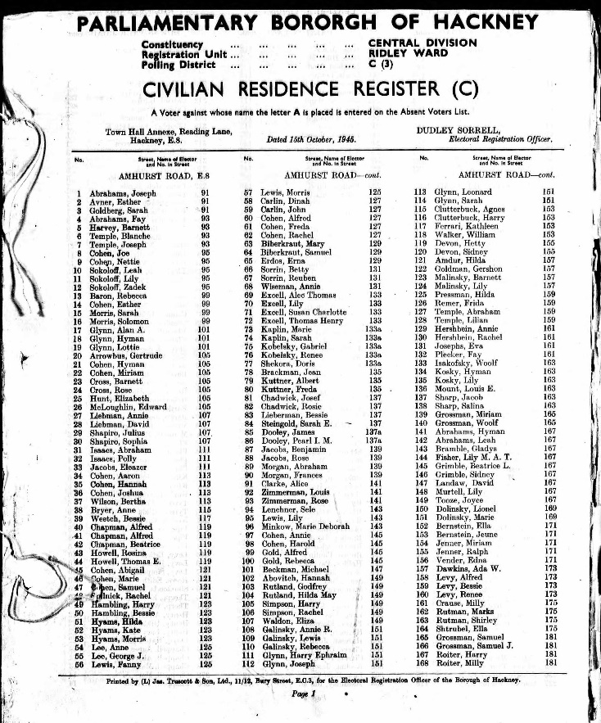1945, Devon, 155 Amhurst Rd 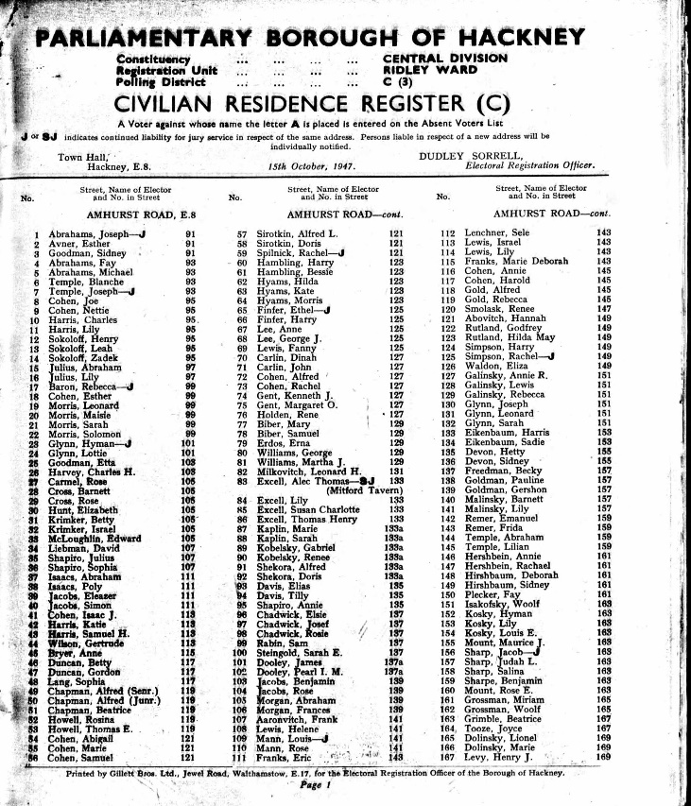1947, Devon, 155 Amhurst Rd
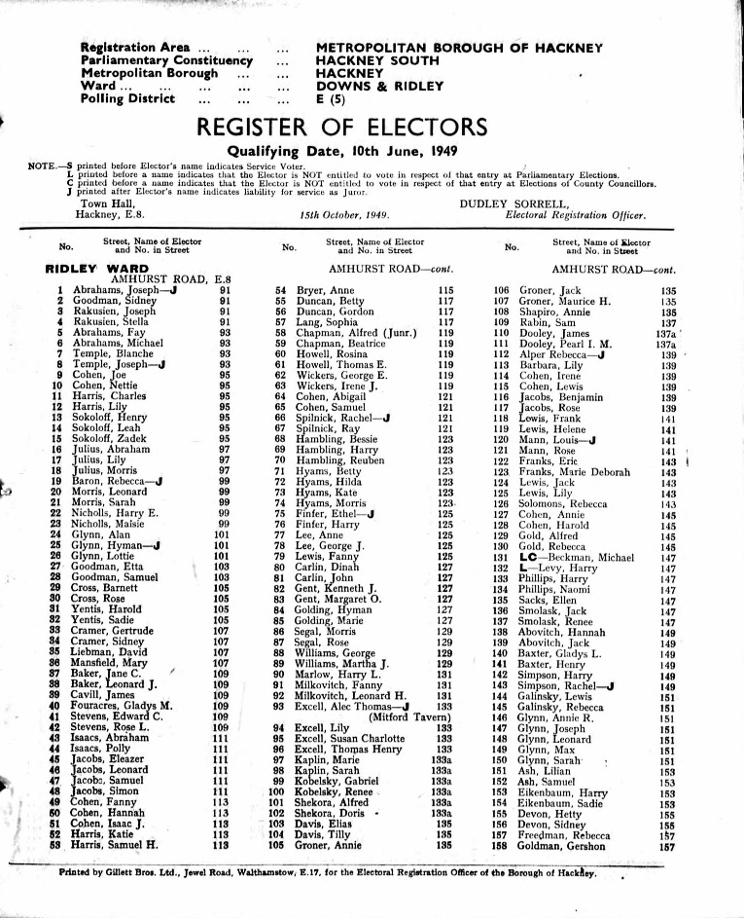1949, Devon, 155 Amhurst Rd
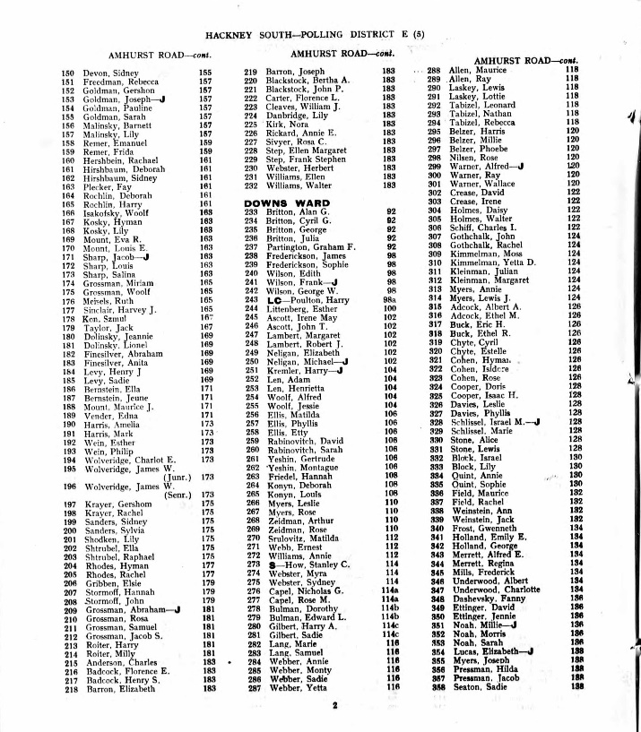1950, Devon, 155 Amhurst Rd
Sidney died on 14 August 1950.
Sidney’s probate record states that he left his money to his wife Hetty. He is buried at Streatham Jewish Cemetery. His headstone reverts to his given name Solly (Solomon) Devan and Harold is commemorated on the headstone using the surname Devan and erroneously has the wrong year of death.
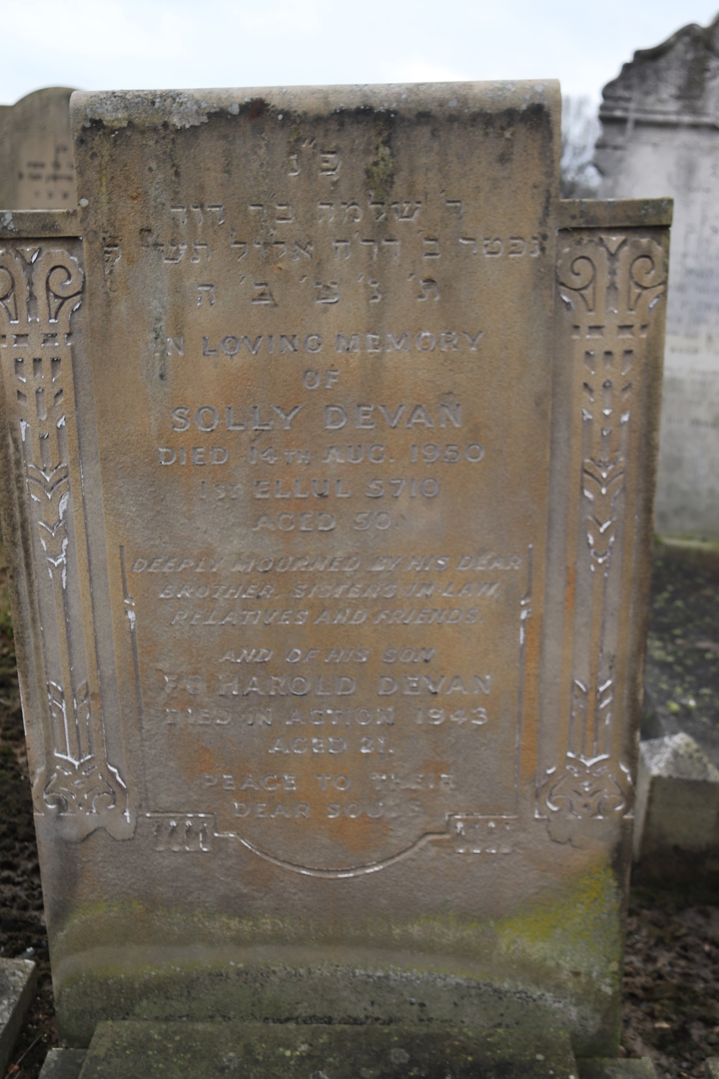
Sidney’s headstone at Streatham Jewish Cemetery
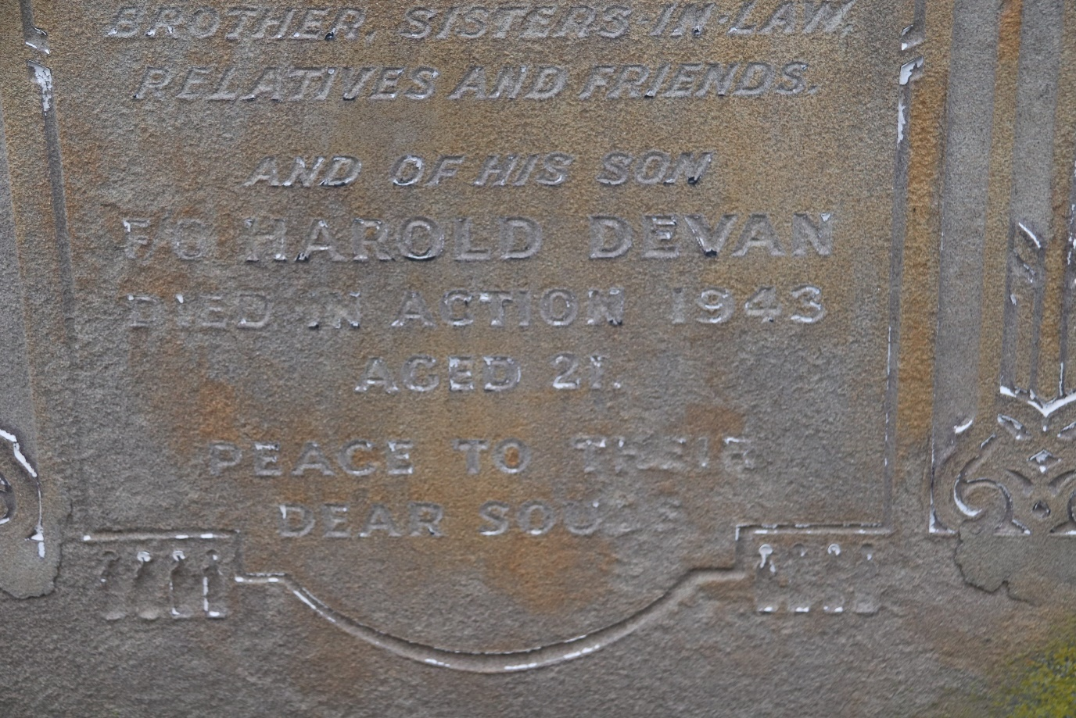
Sidney’s brother Nathan died in 1988 and is buried at Waltham Abbey Jewish Cemetery. It should also be noted that Sidney’s older brothers Samuel and Jacob also changed their surname to Devon. Samuel died in 1939 and both of his children Marie and Freda were given the surname Devon at birth.
Harold was based at RAF Syerston and met Marjorie Ada Roe who worked as a shorthand typist in the WAAF. They married on 12 February 1944 at The Register Office in Nottingham only forty-seven days before he was killed. Their marriage certificate states that Harold was a flying officer and before enlisting was an insurance accountant. The certificate clearly states that Harold’s father was Sidney Devon, and his home address was 155 Amhurst Road, Hackney.
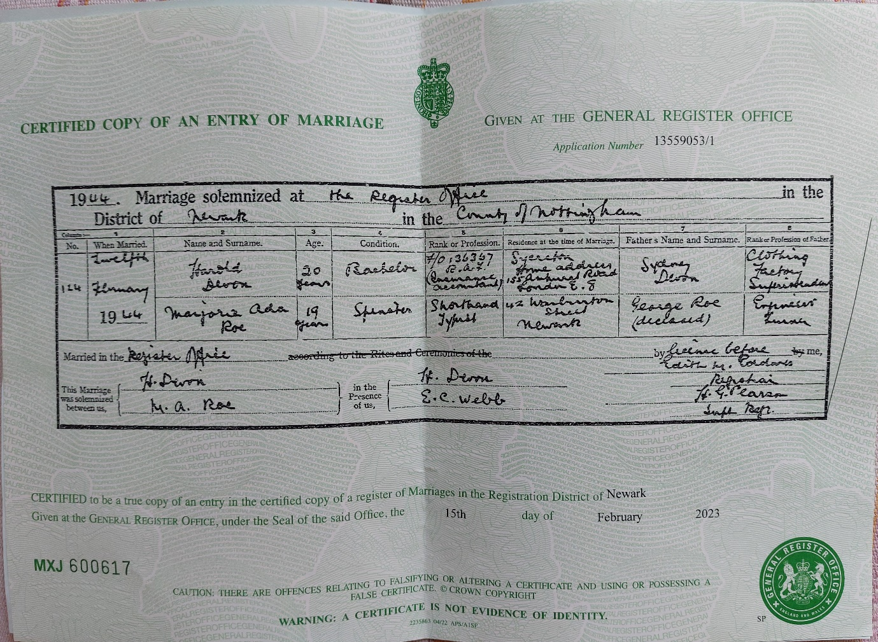
Harold’s marriage certificate

The above information clearly indicates that Harold Devon was Hyman Harold Devan. The letter sent by CWGC to either his father or wife post war had no response and a Cross was added to his headstone by default.

