Alexander Isaac Philip Greene (Greenberg) M.B.E. Cross by default on headstone at Phaleron War Cemetery, Greece. No response from wife in 1947 and 1958 from CWGC letter.
Major Alexander Phillip Greene | War Casualty Details 2932197 | CWGC
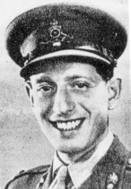
Alexander’s father was Philip Greenberg born 17 July 1893 in Bow, London. He married Rachel Symons on 16 March 1916 at the Walthamstow Synagogue. Philip’s WW1 records state their place of marriage, that he was Jewish and the birth of Alexander. Philip served as a sapper in the Royal Engineers
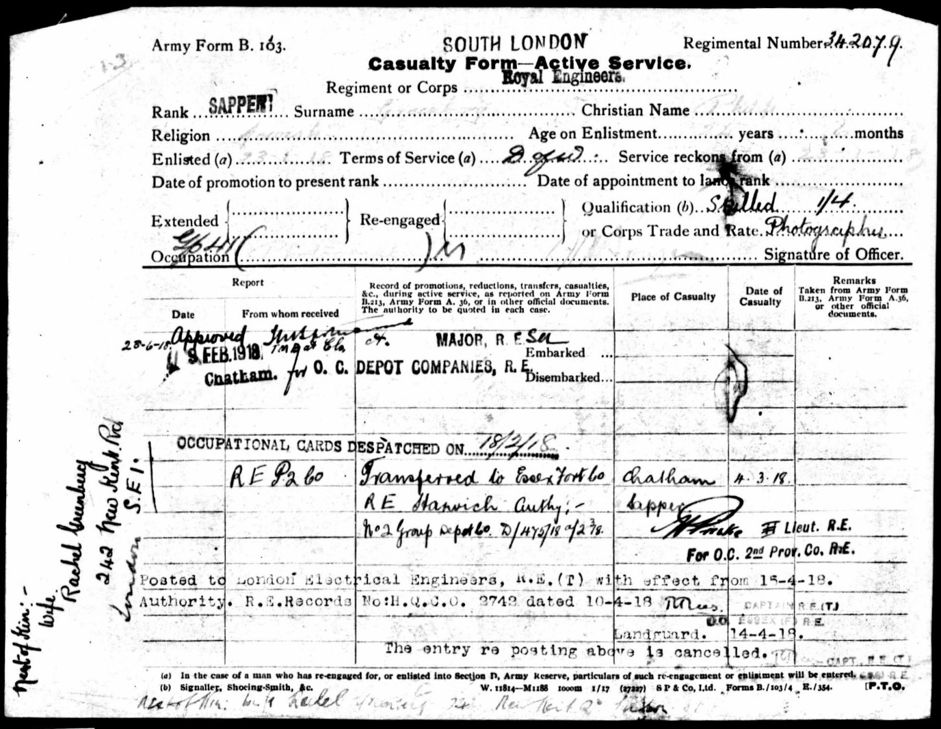
Philip’s Army record stating that he was Jewish.

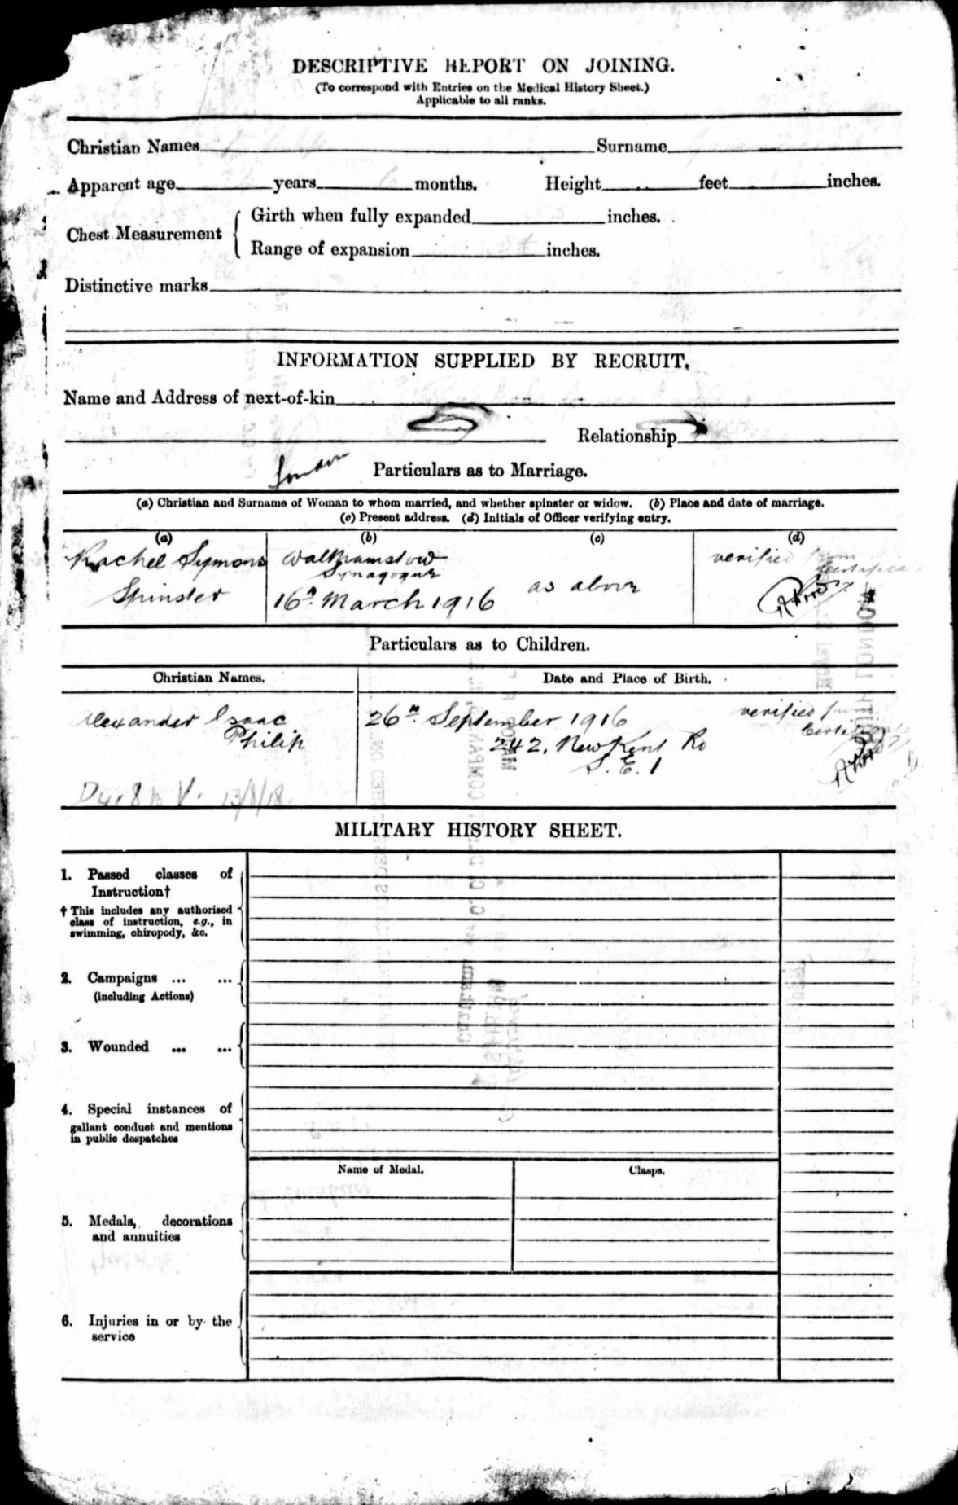
Philip’s Army record stating place of marriage at Walthamstow Synagogue and birth of son Alexander Greenberg
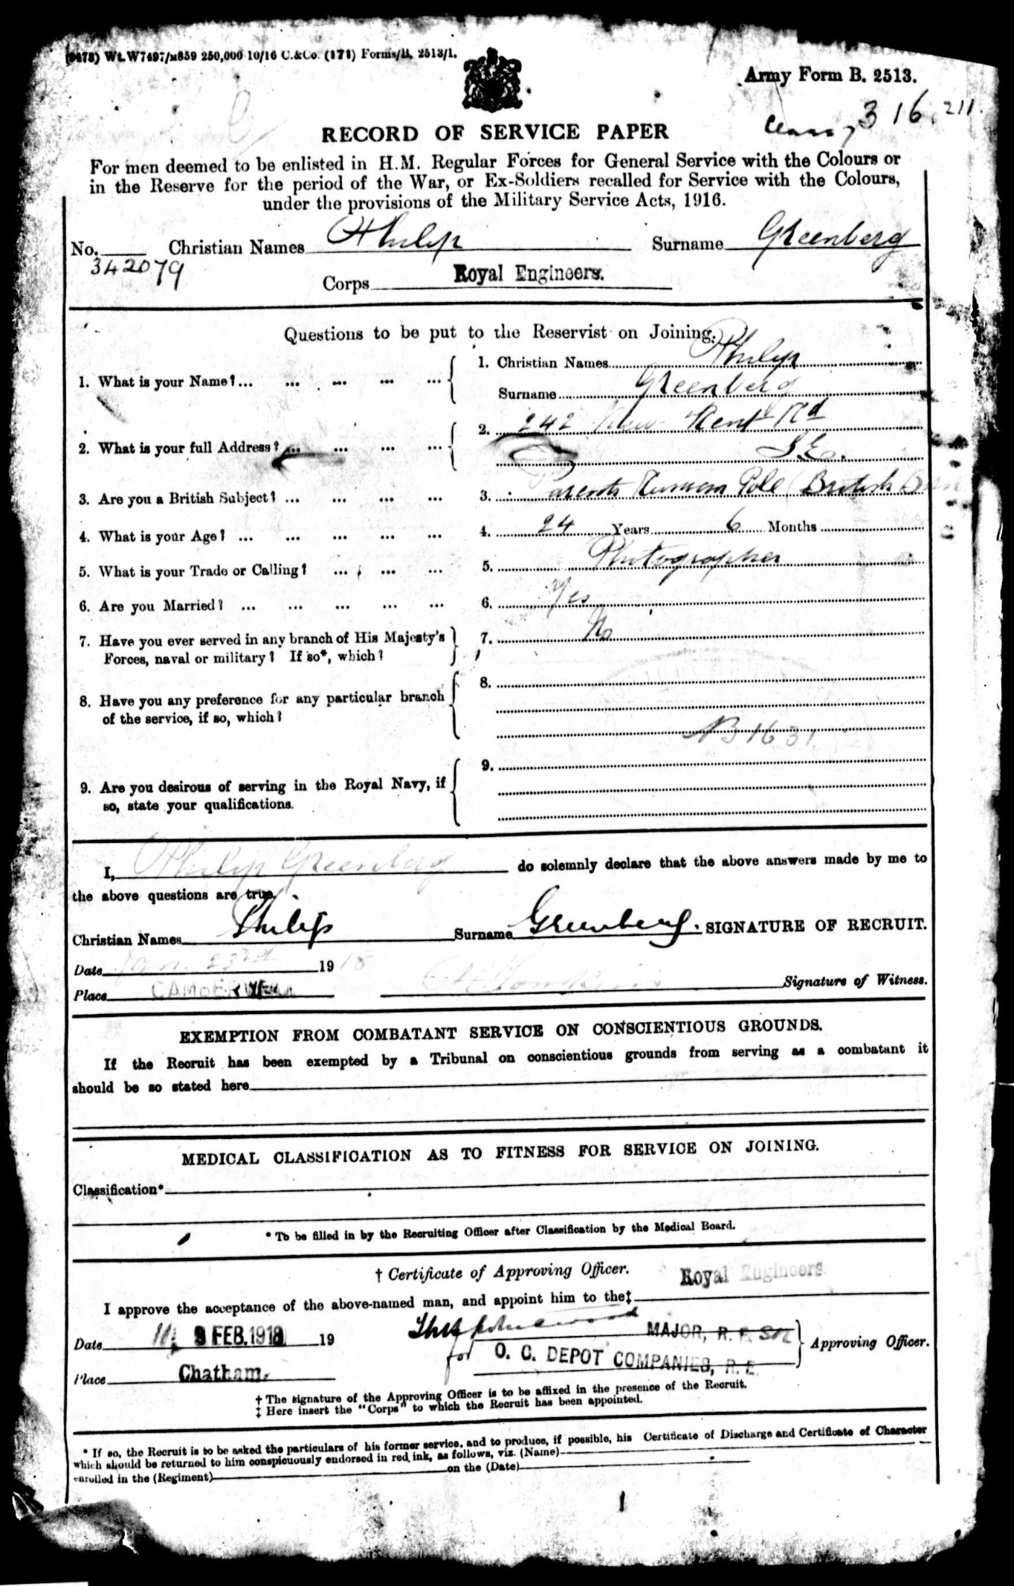
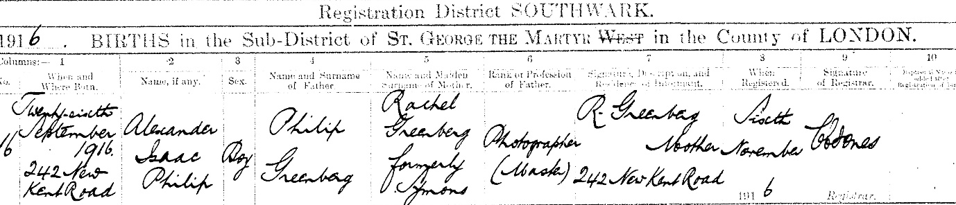
Alexander Greenberg birth. Father Philip and Mother Rachel Symons.

Philip states on his Army records and his son’s birth certificate that he was a photographer.
Alexander’s brother Sidney Henry Greenberg was born in Croydon, Surrey in 1920 and the brothers can be found living with their parents at 242 New Kent Road in Southwark. Their father is still working as a photographer.
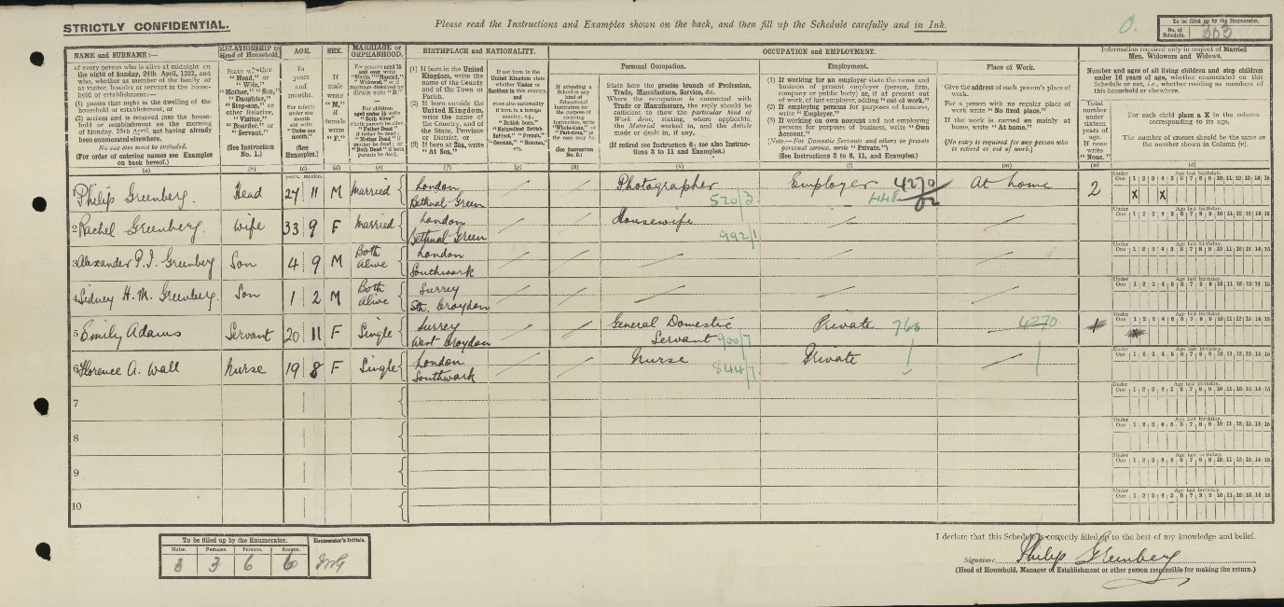
1921 Census
In 1925, Alexander & Philip Greenberg are listed in the Trades Directory as photographers at 242 New Kent Road, SE1 and 37 Borough High Street, SE1.
In 1939, Alexander’s father Philip was living at 12 Barn Rise in Wembley and was working as a radio and cycle dealer. He was now using the surname Greene. His younger son Henry was also working at the radio shop as the manager.
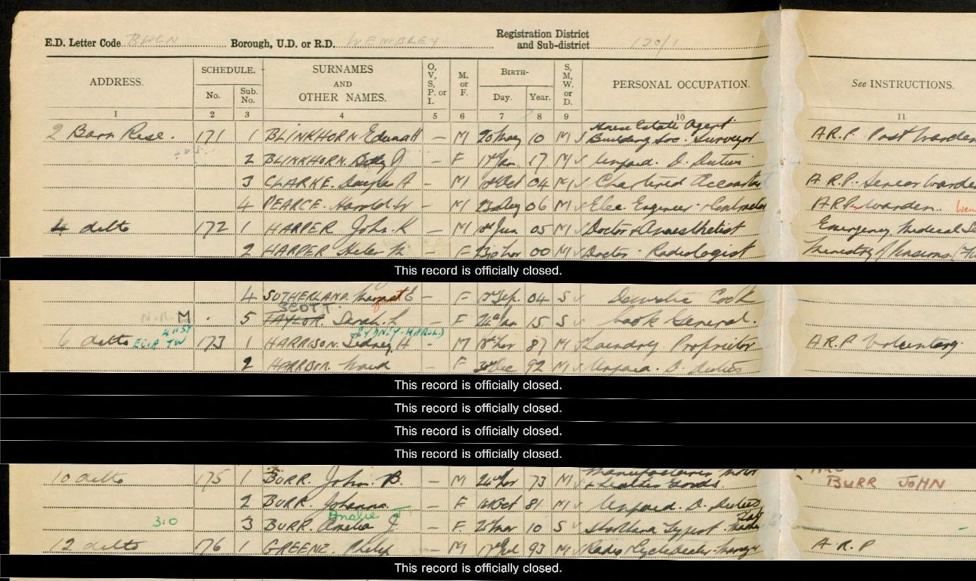
1939 Register for Philip Greene
On 10 June 1939, Alexander, now also using the surname of Greene, married Edith Cooper at the London City registry office. His marriage certificate states his father is Philip Greene, a radio dealer, and Alexander was working as a corporation accountant. Edith was Jewish and her mother was Ada Kisselman and father Percy Cooper whose original surname was Koperschmidt.
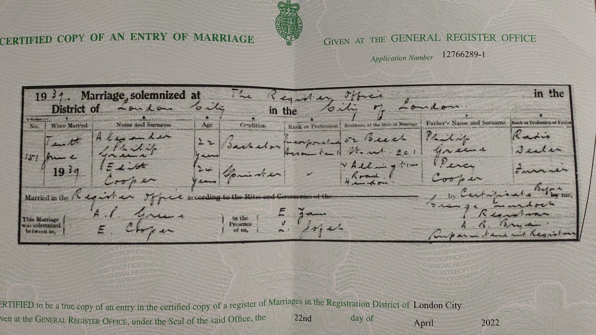
Alexander & Edith’s marriage certificate
Later that same year the polling register states that Alexander and Edith are living at 88 Eton Place, NW3.
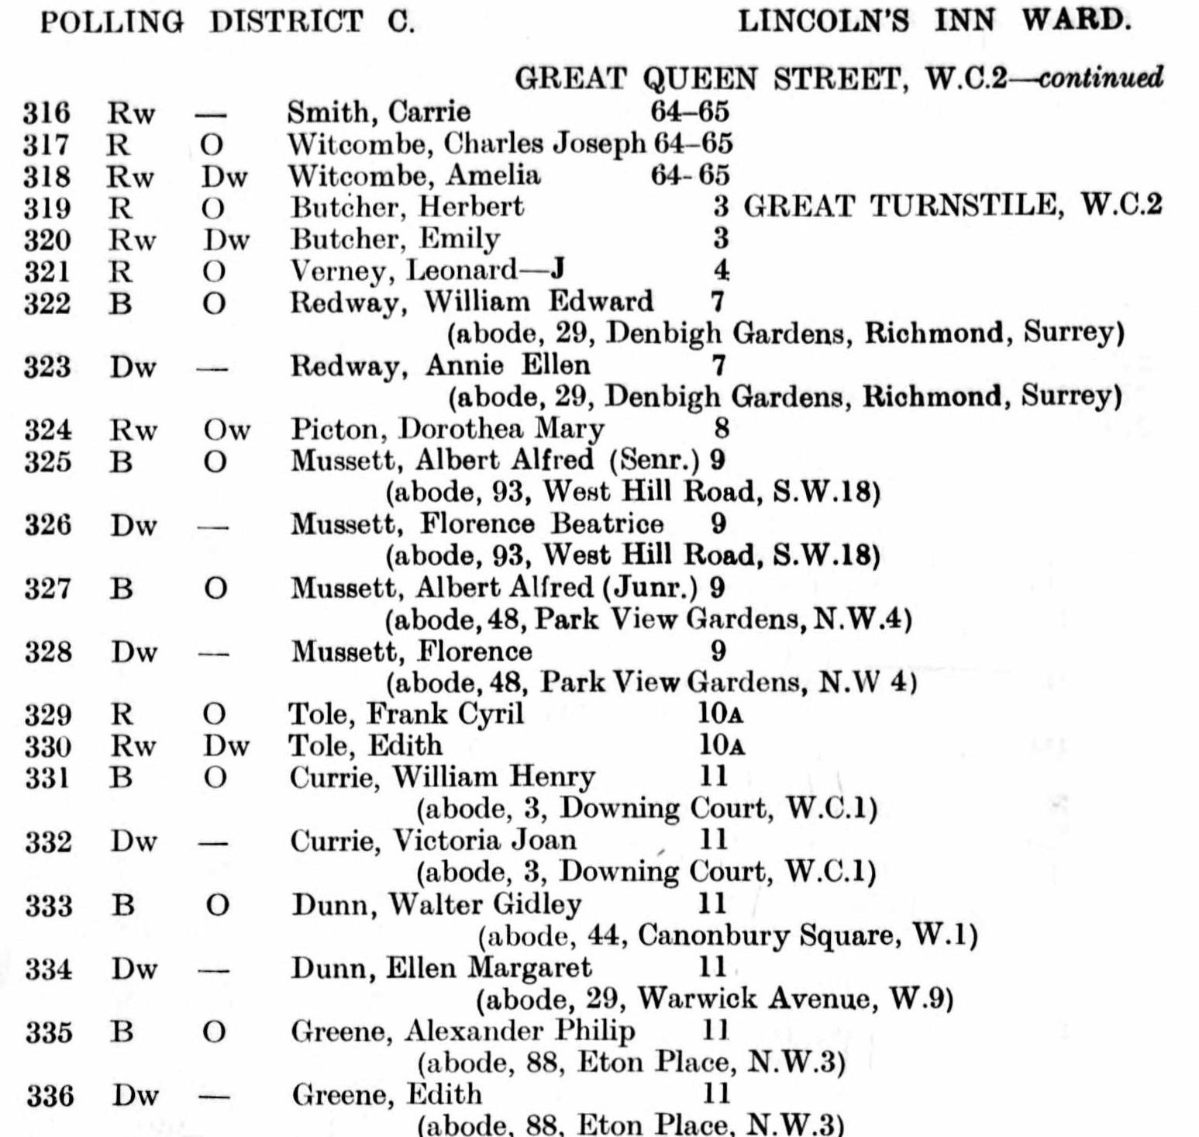
1939 address
Edith was born to Jewish parents Ada Kisselman and Percy Cooper, a furrier, on 19 November 1914 in Mile End Old Town, London. When Alexander attested, she moved to live with her mother Ada and sister Beatrice in Ampthill. The register states that she was working as a secretary and shorthand typist. Her sister Beatrice married refugee Austrian Jewish doctor Eduard Max Tiger whose family were murdered in the Holocaust.
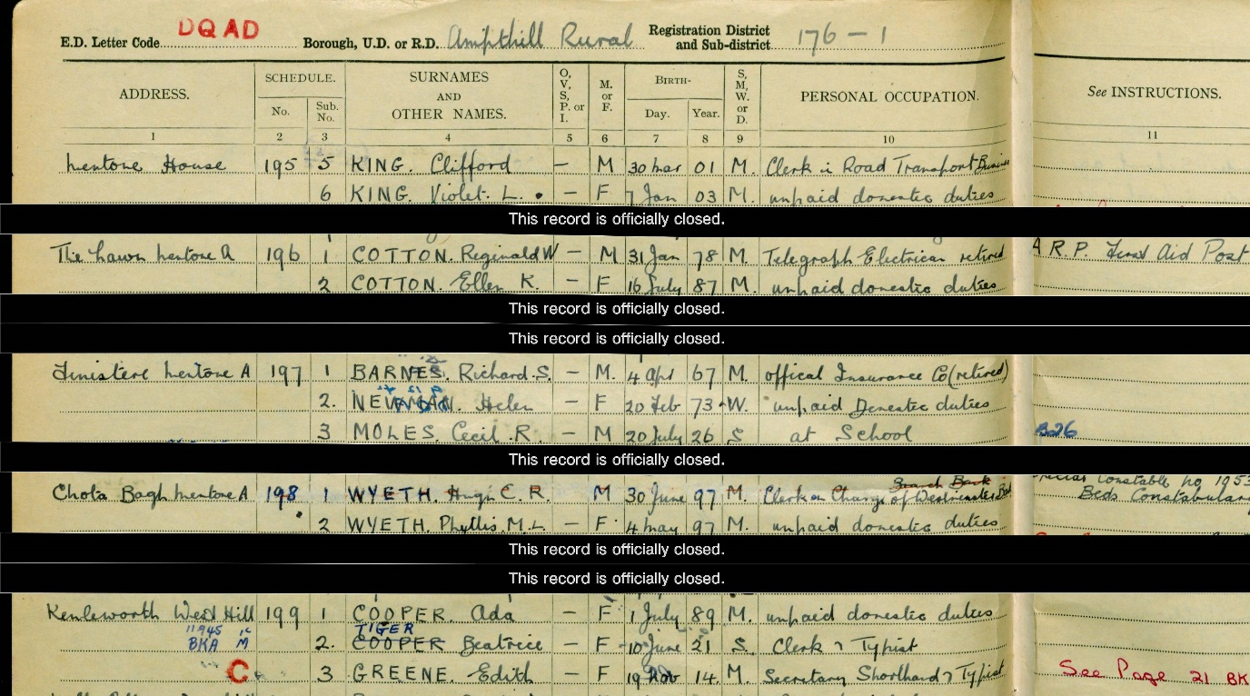
1939 Register. Edith Greene is living with her mother and sister.
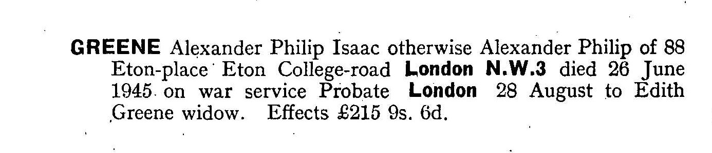
Alexander’s Probate record
Alexander was killed on 26 June 1945. He was mentioned in despatches on 21 June 1945 and posthumously awarded the M.B.E. on 13 December 1945.
•Major (temporary) Alexander Philip GREENE (214986), Royal -Regiment of Artillery (to 'be dated 23/6/45) From The Gazette 13 December 1945
Maj. (temp.) A. P. GREENE (214986). From the Gazette 21 June 1945

Alexanders brother Sidney Henry Greene (Greenberg) was born in 1920 in Croydon, Surrey. He enlisted into the Royal Airforce and was killed serving in 18 Squadron on 4 December 1942. He has no grave and is commemorated on the Malta Memorial. Greene, Sidney Henry | Remembering the Jews of WW2
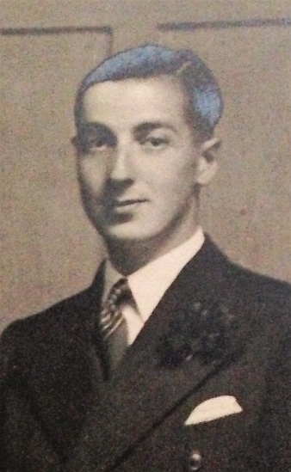Sidney Henry Greene

