Samuel Hantman, buried with a Cross on his headstone
Guardsman Samuel Hantman | War Casualty Details | CWGC
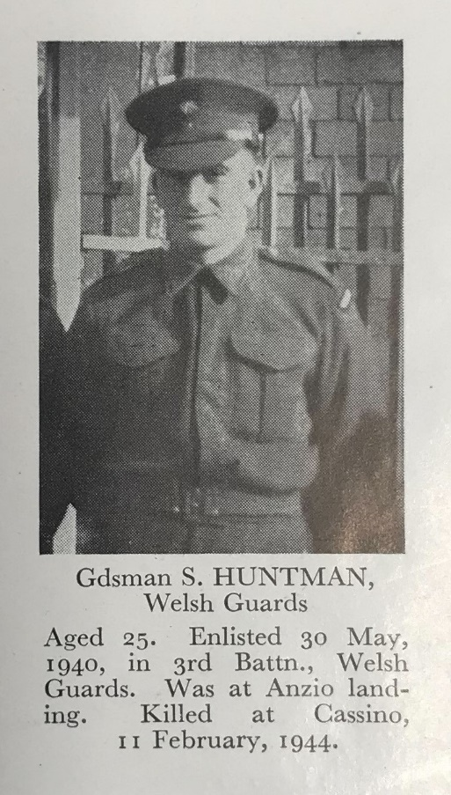
Photo from the book ‘We Will Remember Them.’ Surname is spelt incorrectly.
Samuel’s grandparents were Ouzer Hillel (Henry) born 1873 in Russia, died 1908 in Newcastle. Chana (Annie) nee Boulerowitzky born 1873 in Russia and died 1947 in Newcastle.
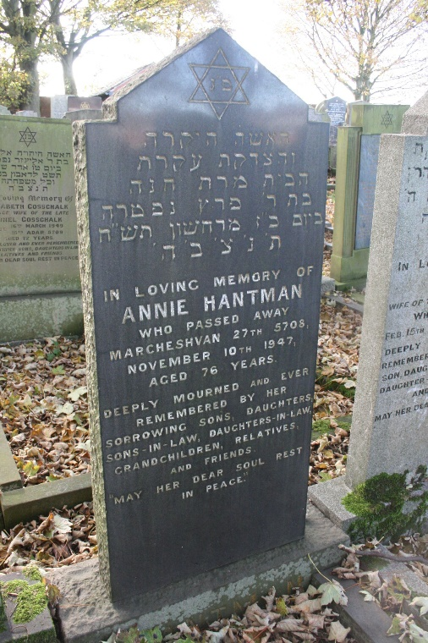
Annie is buried in Ravensworth Jewish cemetery in Newcastle.
Maurice (Moshe), Samuel’s father, was born on 3 March 1890 in Russia the oldest of seven children. The family travelled from Russia to Newcastle where the three youngest children were born, Samuel in 1905, Pauline in 1906 and Caroline in 1907.
Maurice married Emmeline Graham Hughes in Newcastle upon Tyne in July 1912. They had six children with the first five born in Newcastle. Rona 28 Nov 1912, Henry 2 June 1914, Percy 28 Feb 1916, Samuel 12 Oct 1917, Esther 18 June 1920 and Sonia born 1932 in Cardiff.

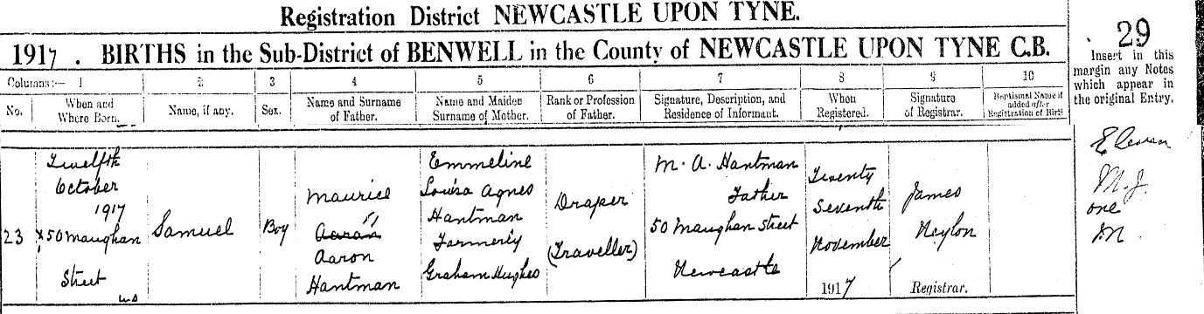
Samuel’s birth certificate
Samuel was born 12 October 1917 at 50 Maughan Street, Newcastle to Russian born Maurice (Moshe) Aaron Hantman and Emmeline Graham Hughes. He had three sisters Rona, Esther, and Sonia and two older brothers Percy and Henry. Henry was killed serving in the Merchant Navy on 20 June 1940.
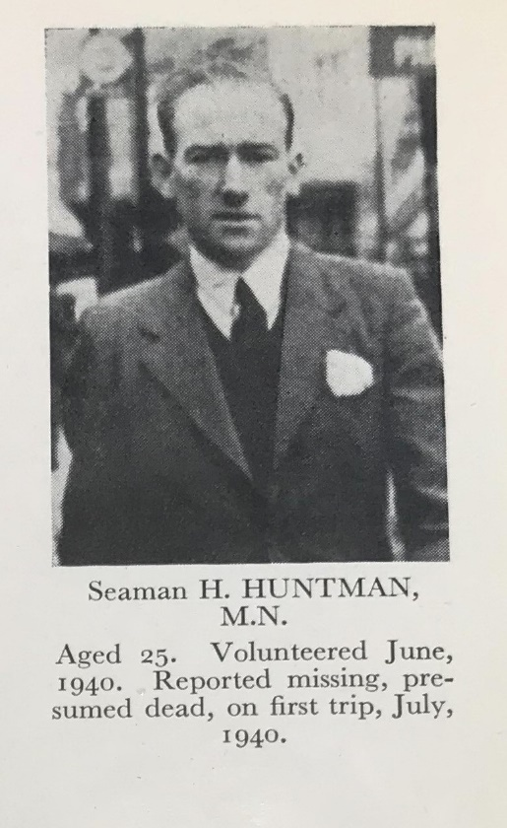
Fireman And Trimmer Henry Hantman | War Casualty Details | CWGC
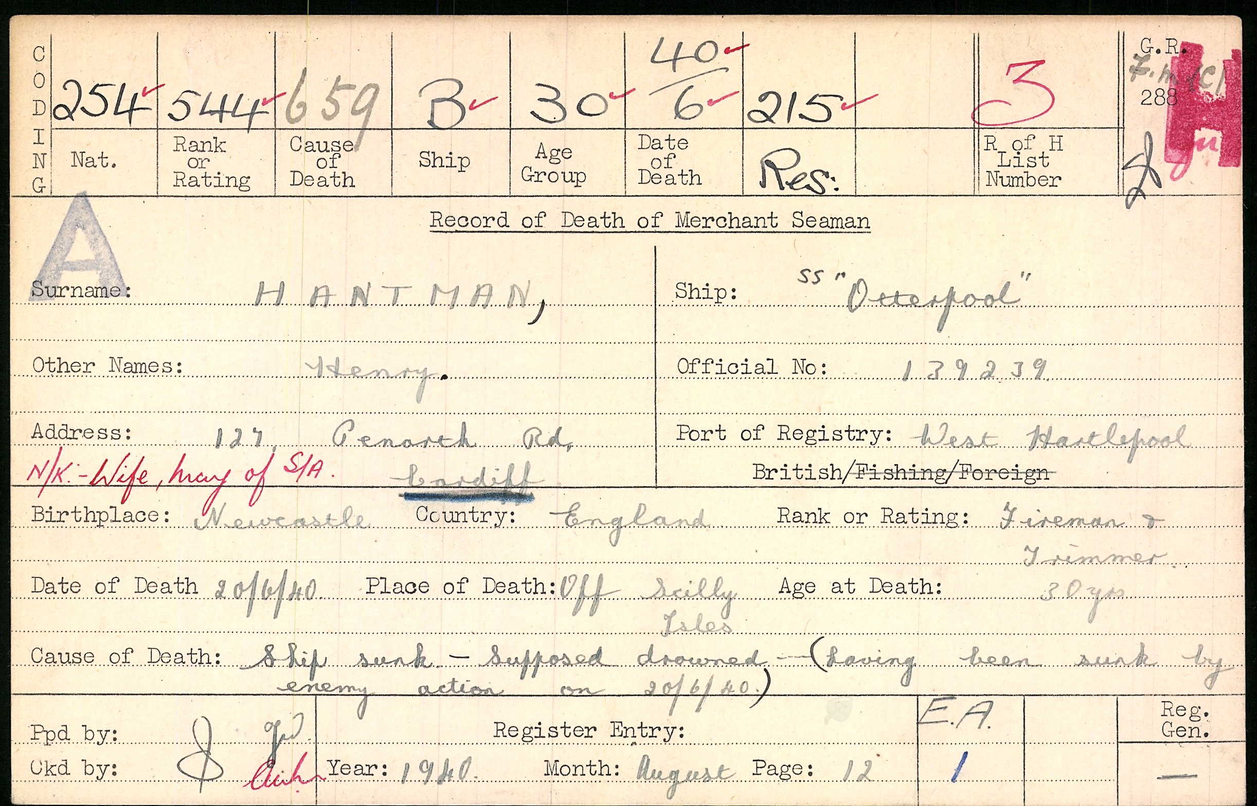
Henry’s Merchant Navy death record

In 1921, the family were living at 38 Fullerton Place, Gateshead and Maurice was listed as working as a draper from home and they had a domestic servant. On the night of the census Emily was visiting friends at Market Place, Barnard Castle.
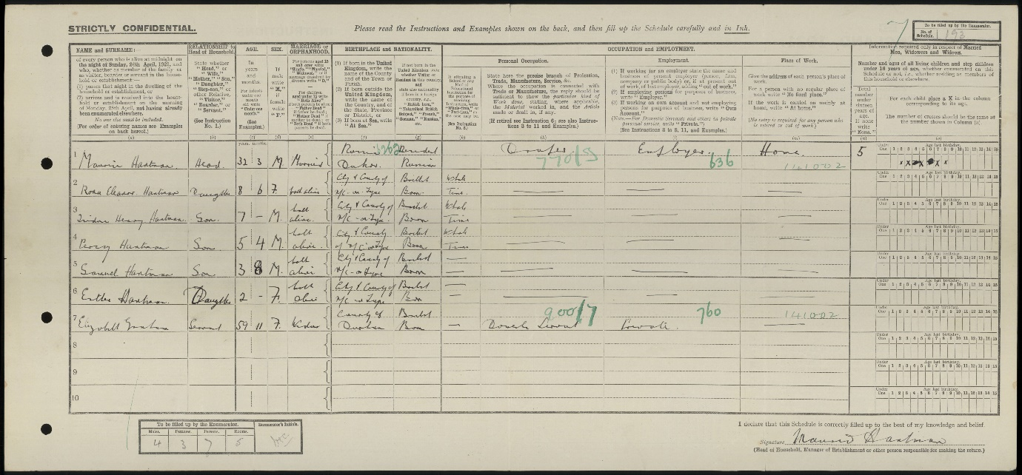
1921 Census
On 16 July 1923 a newspaper article stated that Maurice was arrested in Cardiff on a charge of deserting his wife and five children, and of having, as an alien, failed to notify his change of address. He was fined 40 shillings and sent to prison for 1 month.
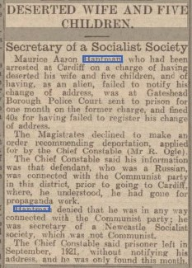
Emmeline and the children then moved to Cardiff where Samuel attended South Church Street school in Cardiff followed by Cathedral Road Synagogue classes. Emmeline died in Cardiff in 1938.
The 1939 Register shows Samuel living at 36 Christina Street, Cardiff and working as a dock labourer. Later that year he moved back to Newcastle upon Tyne living at 40 Stanton Street the same address as Elsie Allan whom he married in January 1940 in Newcastle. Samuel then enlisted into the Welsh Guards on 30 May 1940.
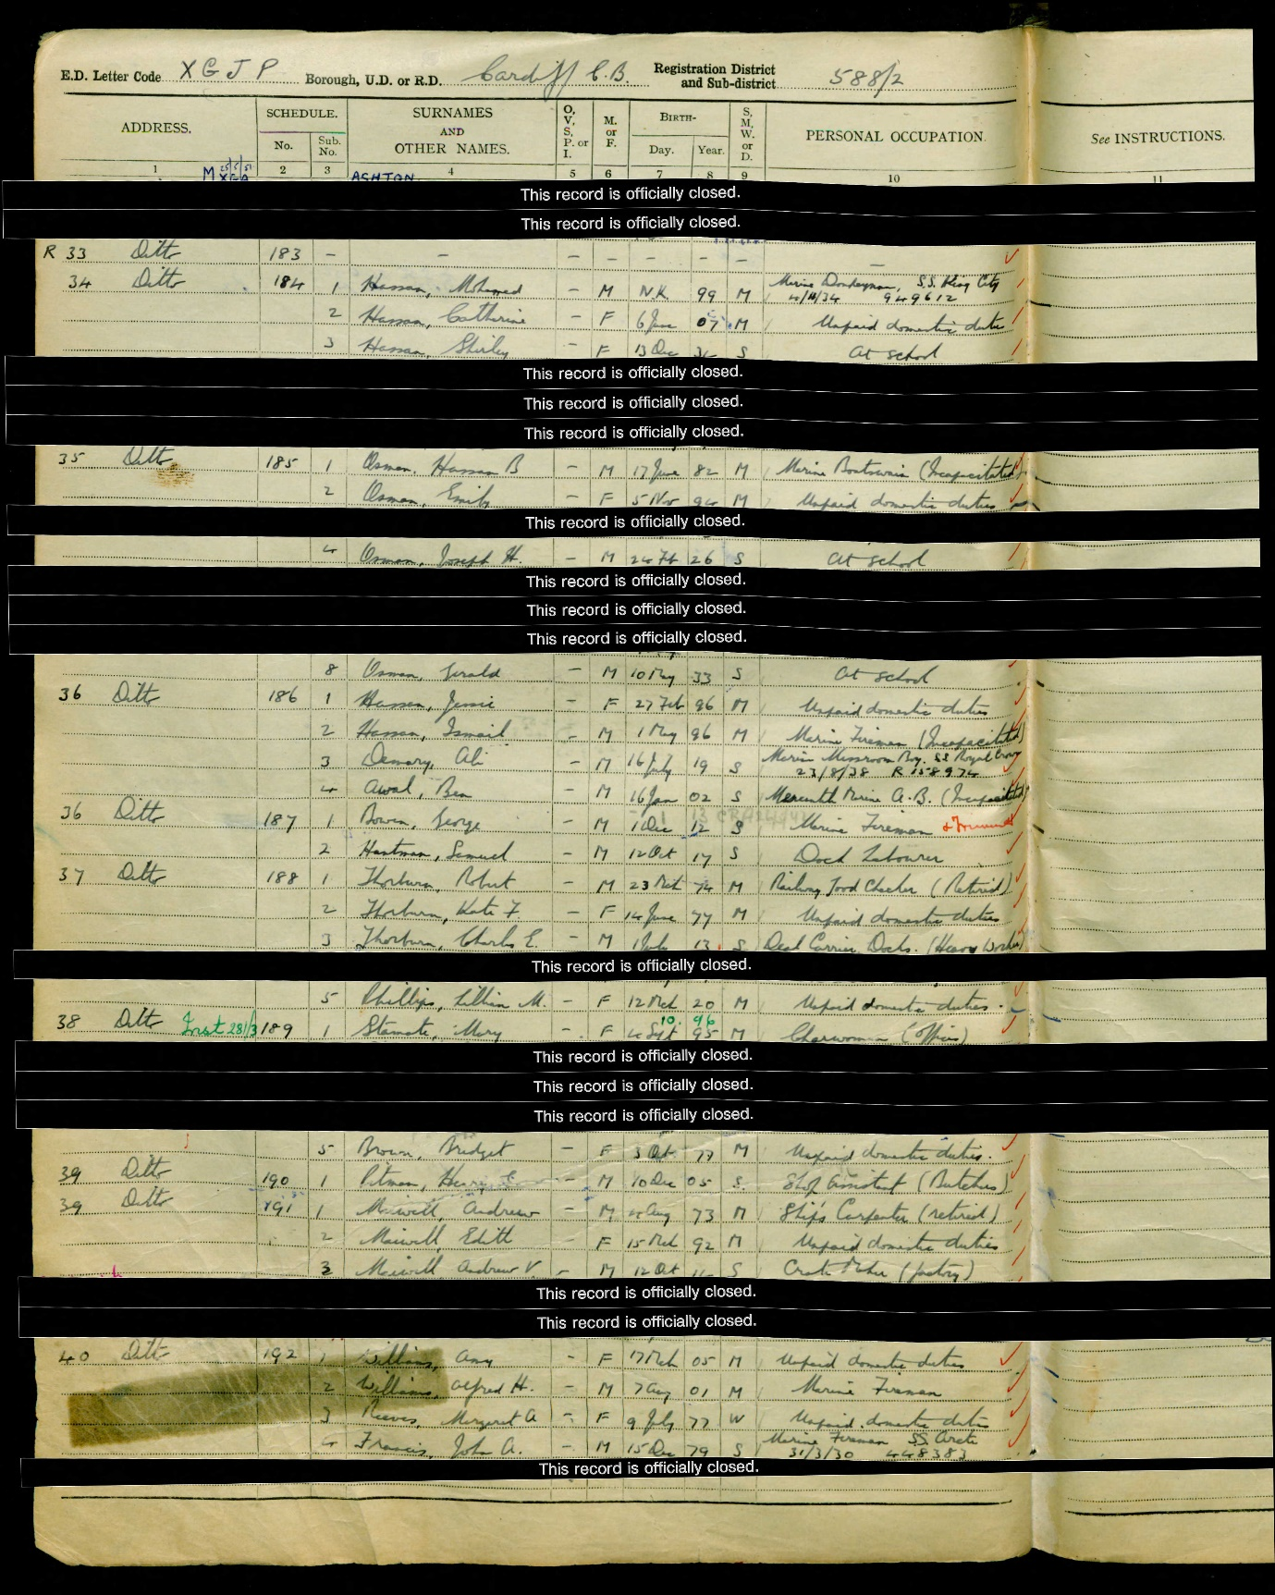
1939 Register
Samuel’s older sister Rona married William Morgan in Newport, Monmouthshire on 1 June 1940 and she died seven months later on 3 Jan 1941 aged twenty-eight only six months after her brother Henry was killed at sea on 20 June 1940.
Samuel’s father Maurice died ten months after him on 4 December 1944 and is buried in Cardiff Jewish cemetery. Maurice was the chairman of Cardiff Jewish institute and social club.
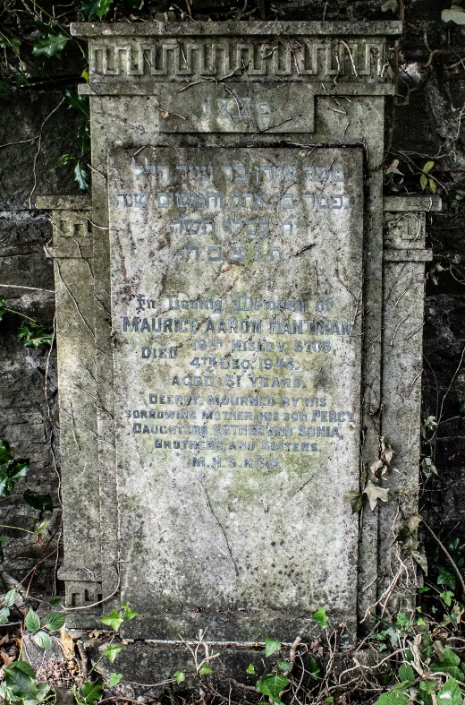 Maurice’s headstone
The following articles are from the Jewish Chronicle archives.

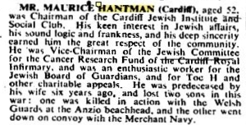
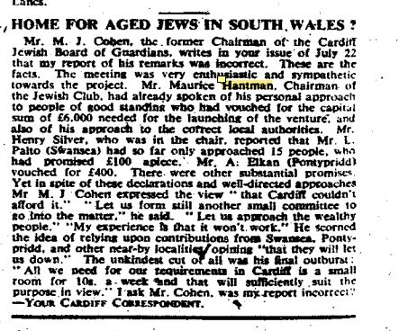

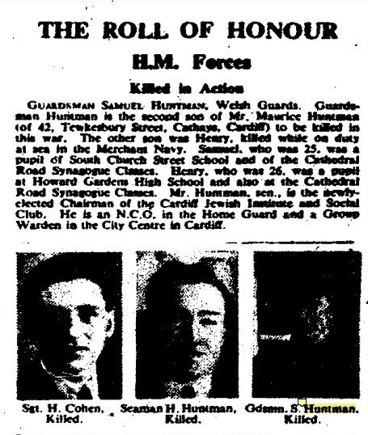
Jewish Chronicle article 17 March 1944 states that Samuel was a pupil of South Church Street School and of the Cathedral Road Synagogue Classes.
