Harold Allentoff. Not recognised by CWGC. Application to have a CWGC headstone for Harold as he died in 1946 whilst serving.
Harold was born on 25 July 1925 in Liverpool, Merseyside to Russian born father Abram (Abraham) and Prestwich, Lancashire born mother Leah (Lily) Pevasky.
Harold’s grandparents were Barnett Allentoff born 3 January 1876 in Belarus, and Rebecca nee Singer. They had Sophia born 25 December 1898 in Belarus, Abraham born 21 November 1902 in Belarus, Lily born London, Ada born London, Cissie born 22 Jan 1907 in Manchester, Sarah 27 Jan 1909 in Manchester and Rosie born 28 September 1911 in Liverpool.
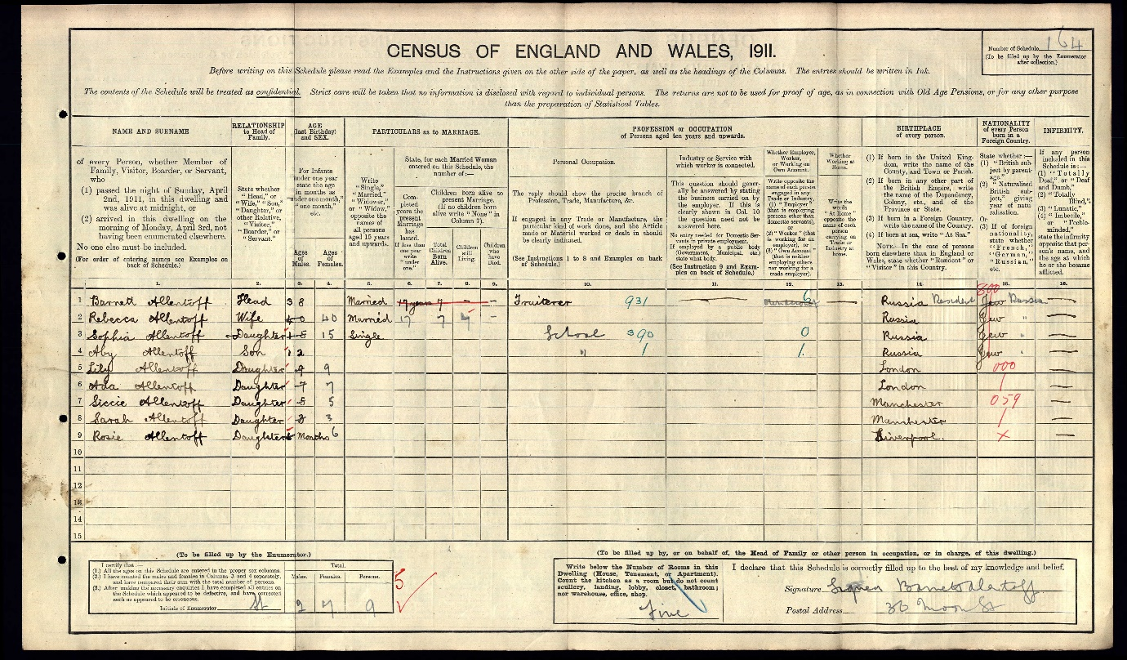
1911 Census
Barnett worked as a fruiterer and in 1911 the family were living at 30 Moon Street in Liverpool.
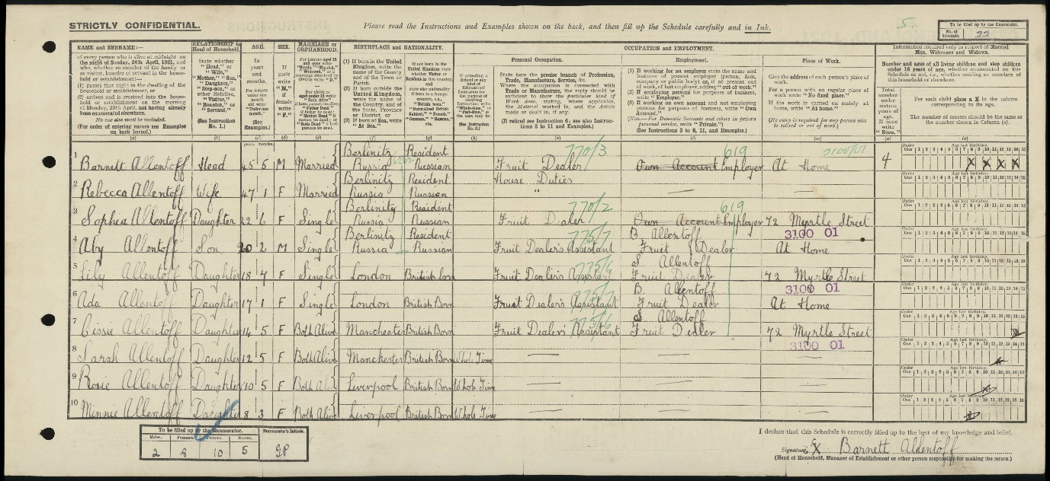
1921 Census
By 1921, the family had moved to 34 Crown Street, Liverpool and apart from the three youngest children who were at school, they all worked in the fruit dealer business based at 72 Myrtle Street in Liverpool.
Rebecca died 14 December 1933 in Liverpool and is buried at Rice Lane Jewish cemetery in Liverpool.
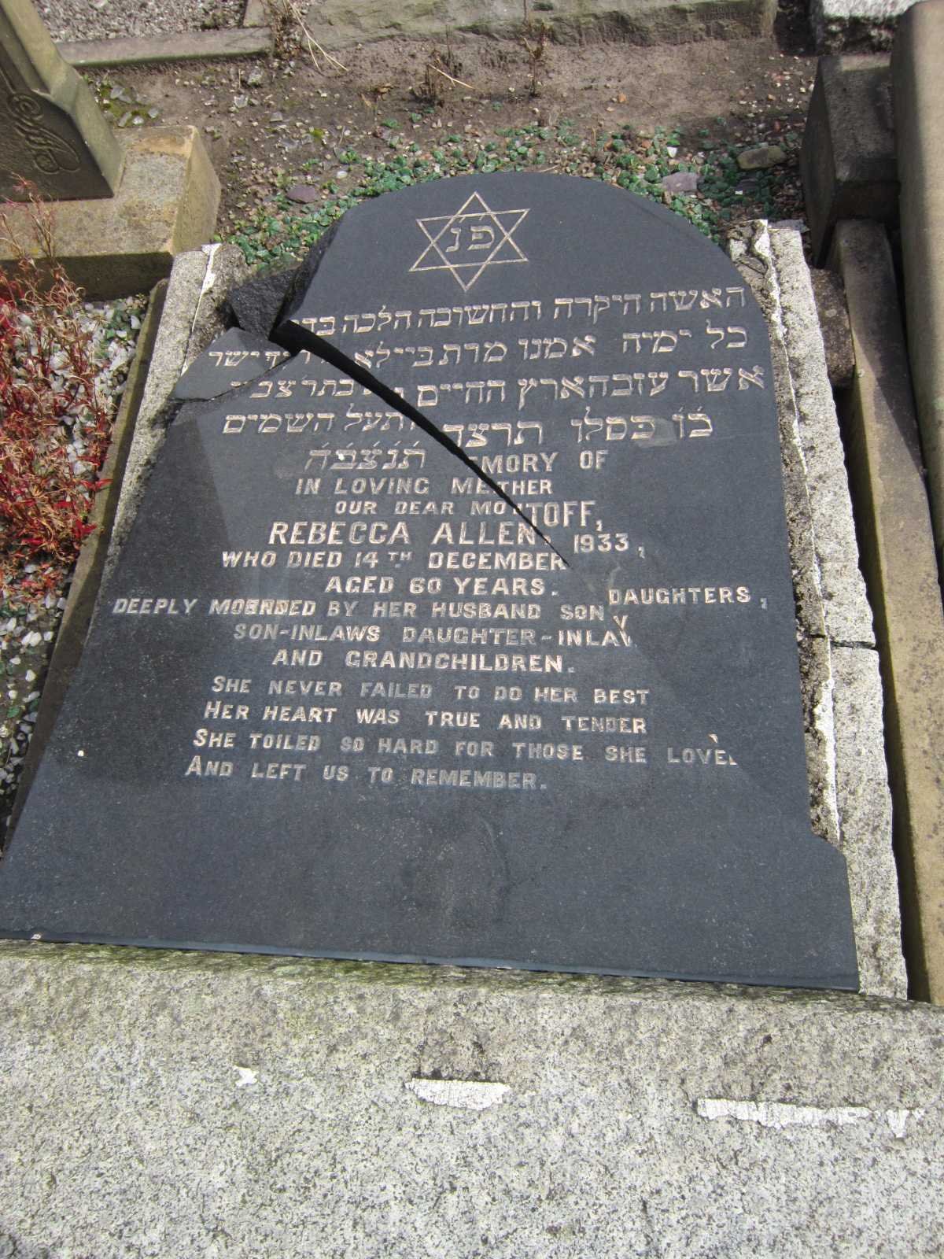 Rebecca’s headstone
Barnett remarried to Annie Mitsky, who was divorced from Joseph Bernstein, and they had one son Harry born 17 June 1920. It is thought they married after 1939. On the 1939 Register they are living together at 22 Crown Street, Liverpool. Annie is listed as divorced and Barnett a widower.
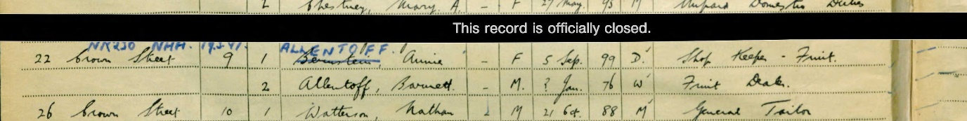
1939 Register
On 29 November 1940, the oldest sister Sophie (41) who had married Frank Goldberg (42) and had one son, and the youngest sister Rosie (29) were killed at 69 Granby Street, Liverpool due to enemy bombing.
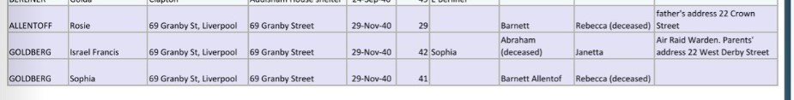
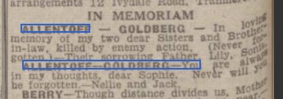Jewish Chronicle
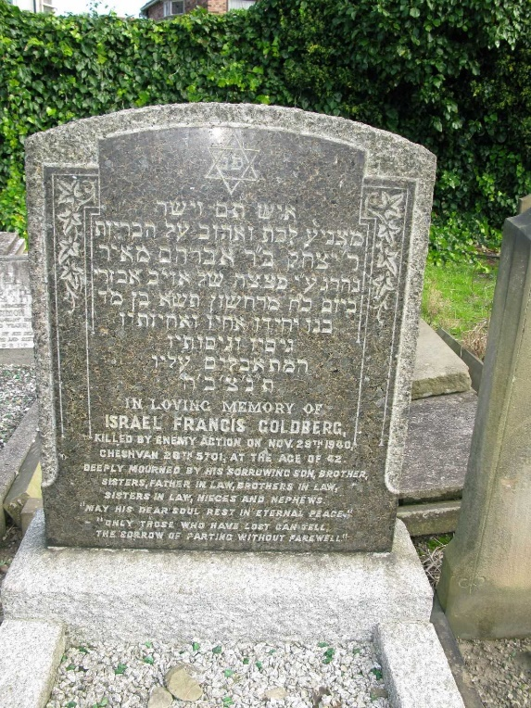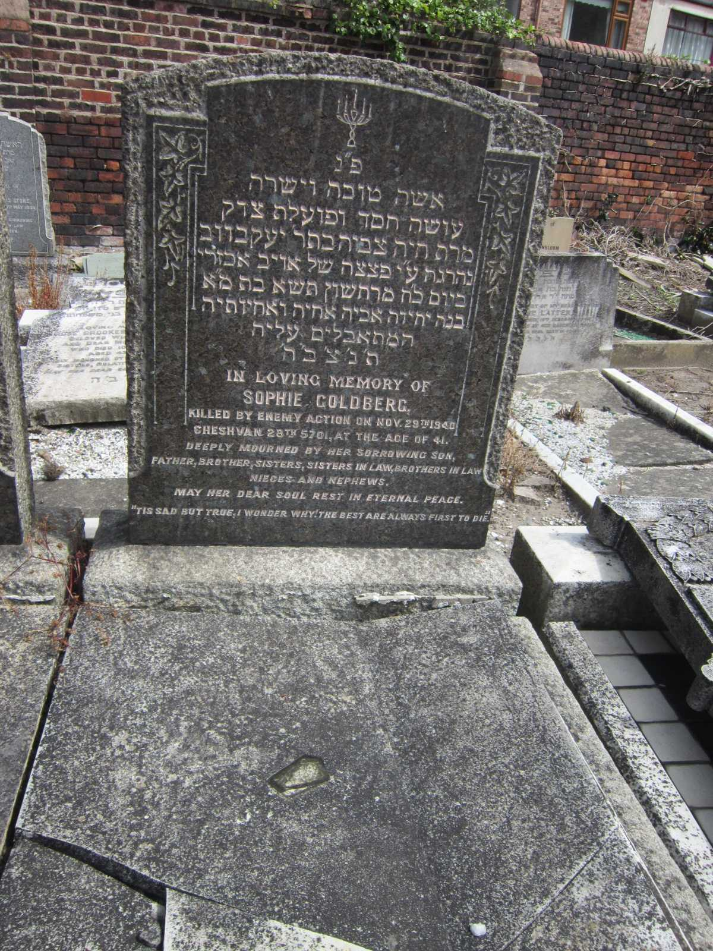
Israel & Sophie
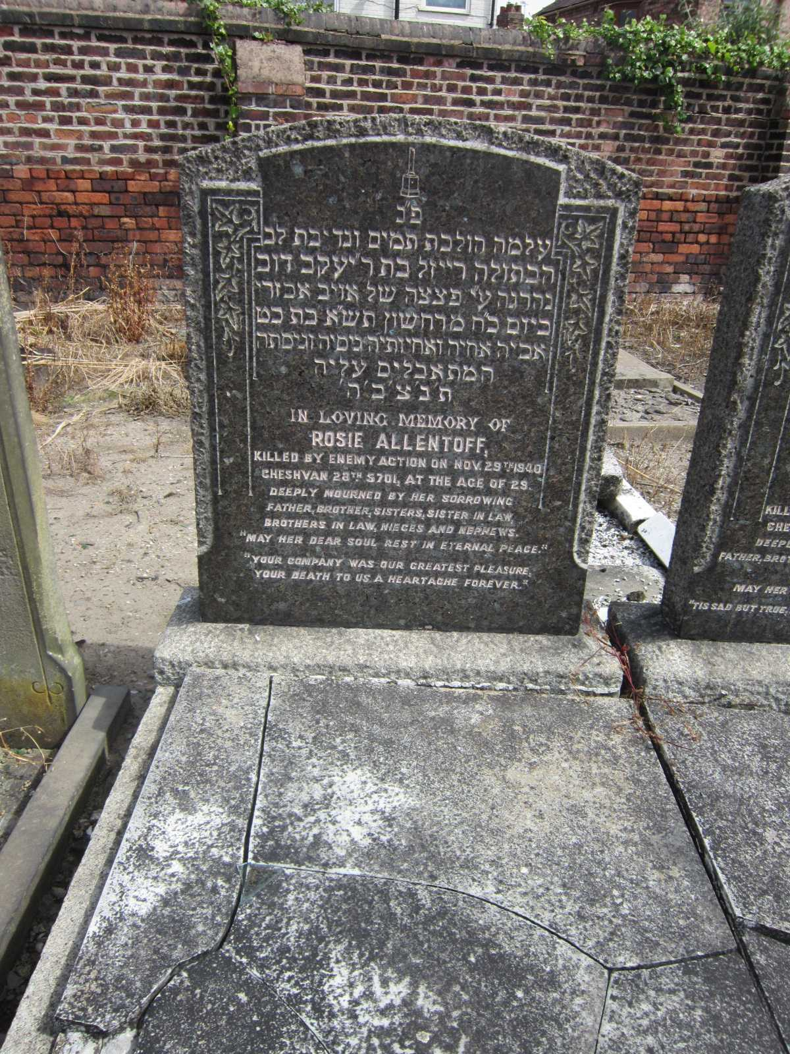 Rosie
Barnett died in 1954 and Annie in 1977.
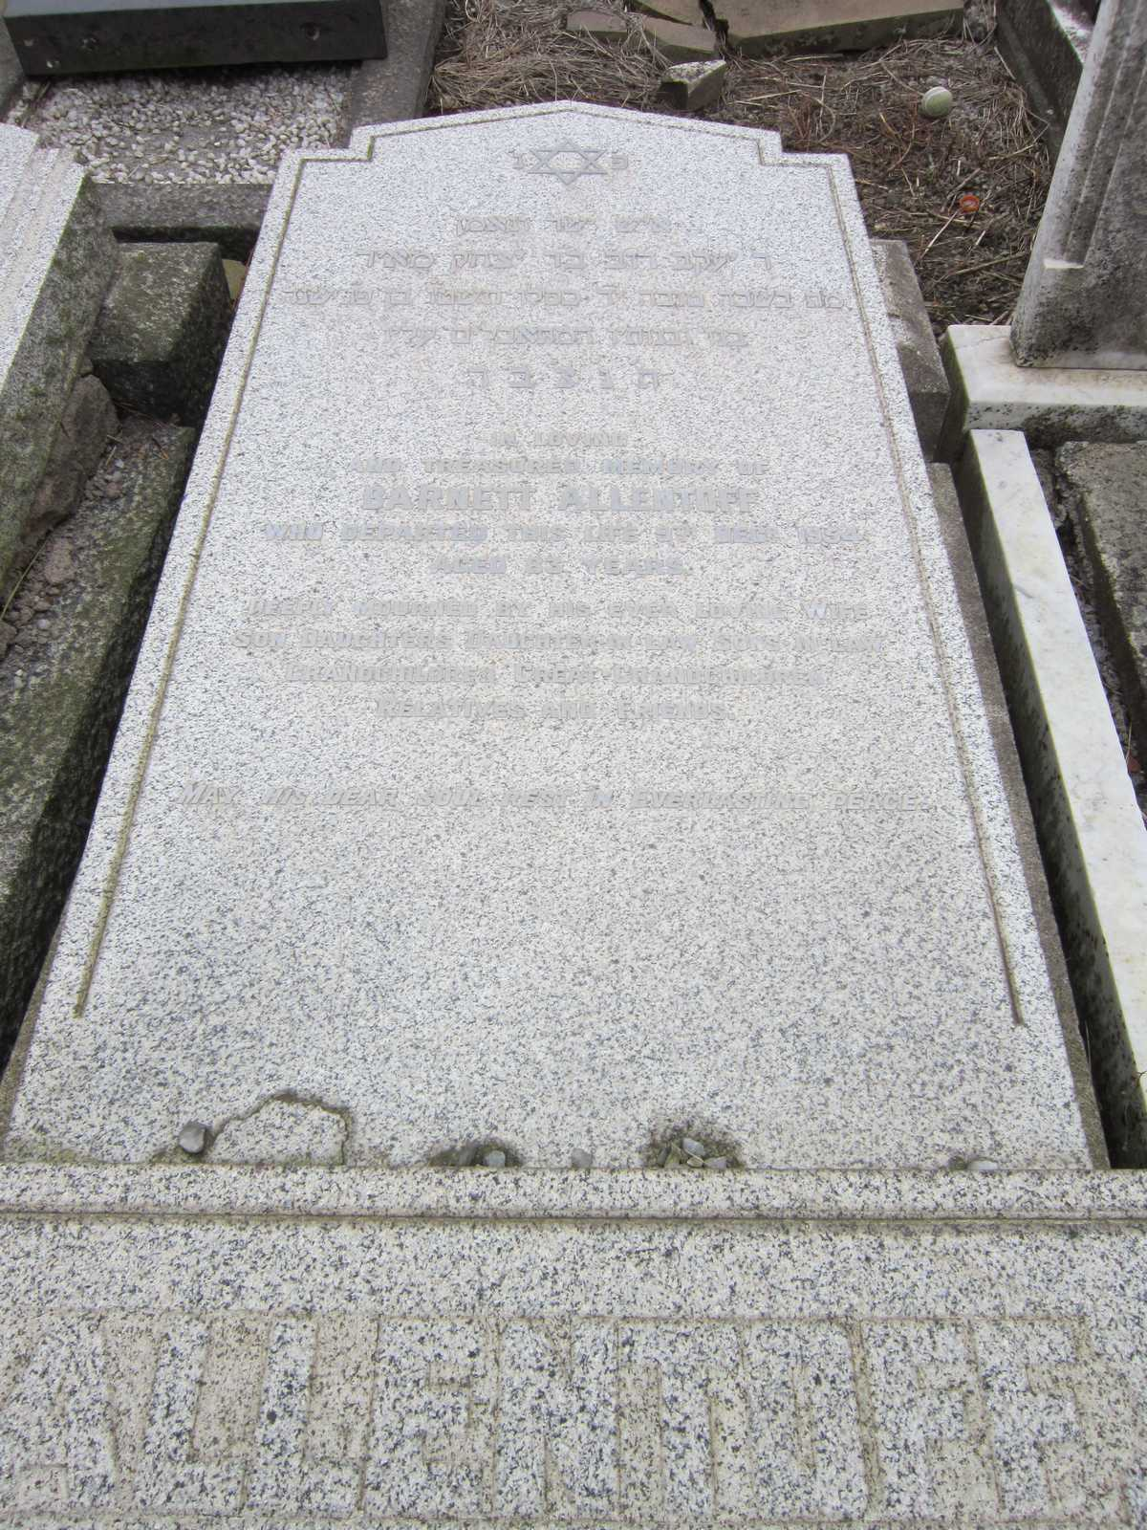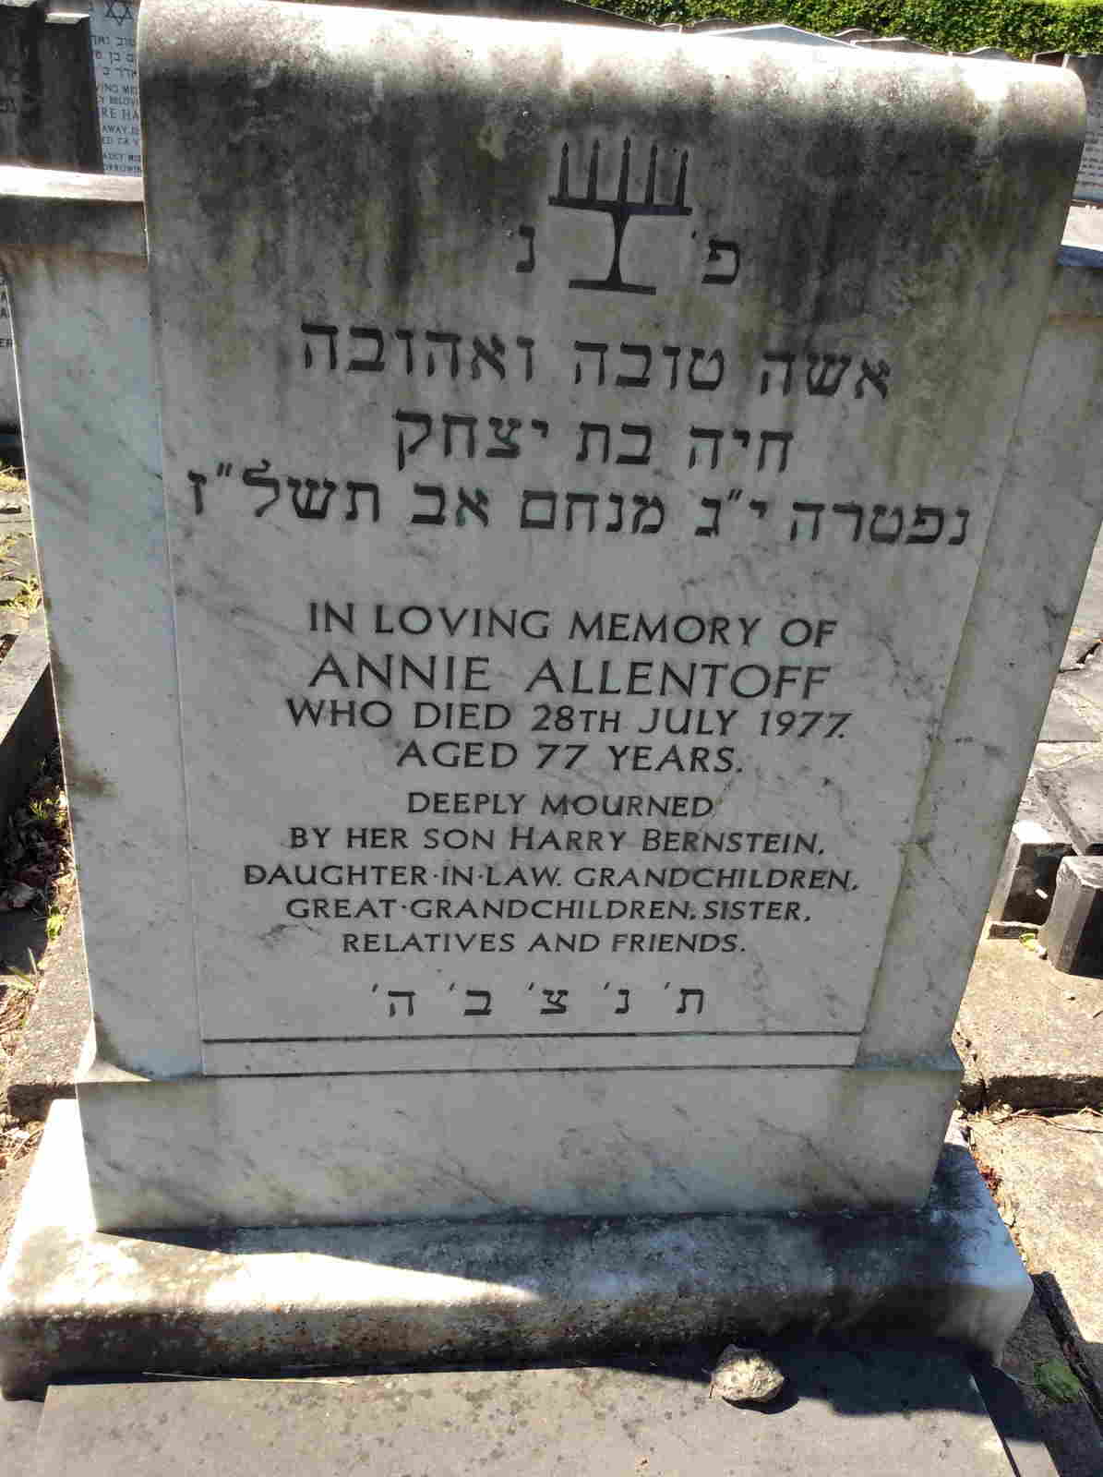
Barnett is buried at Rice Lane Jewish Cemetery and Annie is buried at Springwood (Allerton Cemetery) in Liverpool
Abraham, Harold’s father married Lily (Leah) Pevasky in 1922 at Hope Place Synagogue, Liverpool.
They had two children born in Liverpool; daughter Esther was born on 14 October 1923 followed by Harold on 14 July 1925. Abraham continued with the family fruit dealer business and after finishing school Harold also worked in the business, eventually becoming the manager. Allentoff’s Fruit dealers were still trading in 1952 and the premises are shown on the photo below with the shop on the right of the picture.
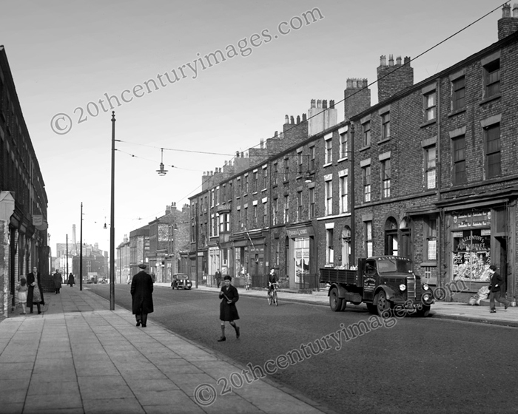
St James’s Place in 1952. Allentoff’s Fruit Market. Eating apples ‘6d a lb’ & ‘Large oranges 4d’.
Harold enlisted into the Army into The Kings Royal Regiment on 16 March 1944, with his Army records showing that he attested as Jewish, before being transferred to the Essex Regiment in February 1945 where he served in Italy gaining the Italy Star War medal. On 3 July 1946 he was granted twelve weeks compassionate leave and was at home in England when he died.
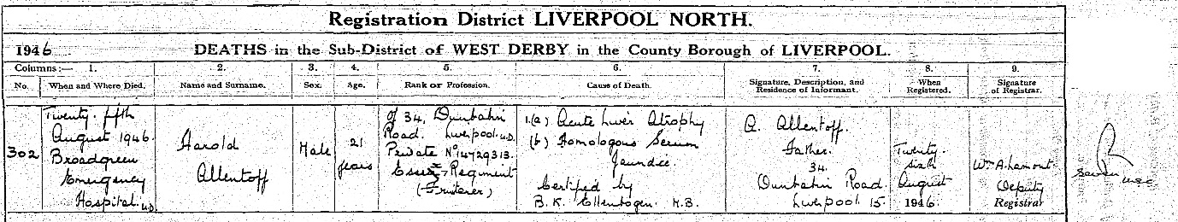
Harold’s death certificate stating that he died at Broadgreen Emergency Hospital from 1(a) Acute Liver Atrophy (b) Homologous Serum Jaundice. His death certificate also states that he was Private No 14729313 Essex Regiment (Fruiterer).
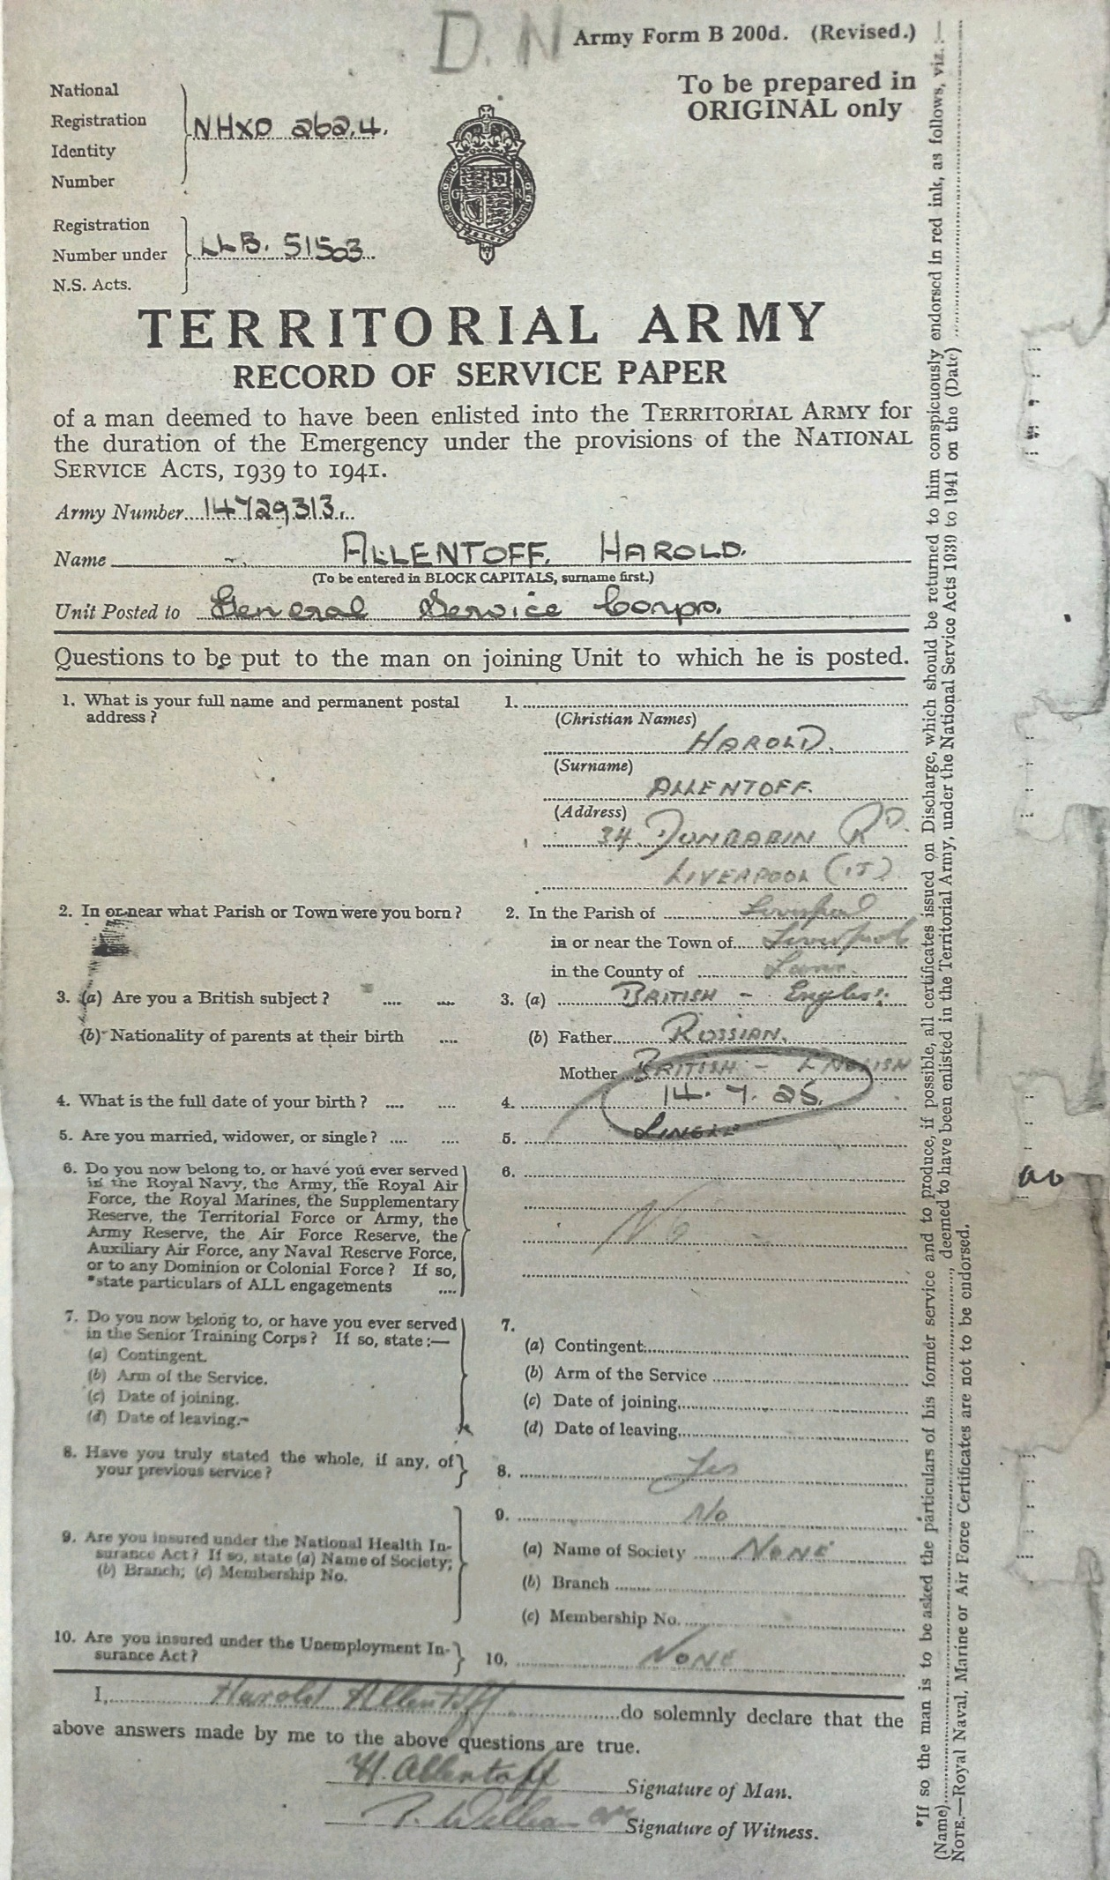
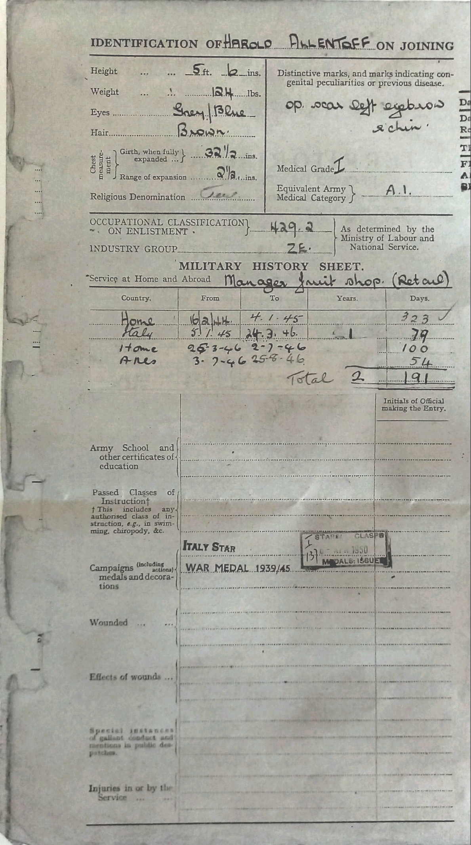
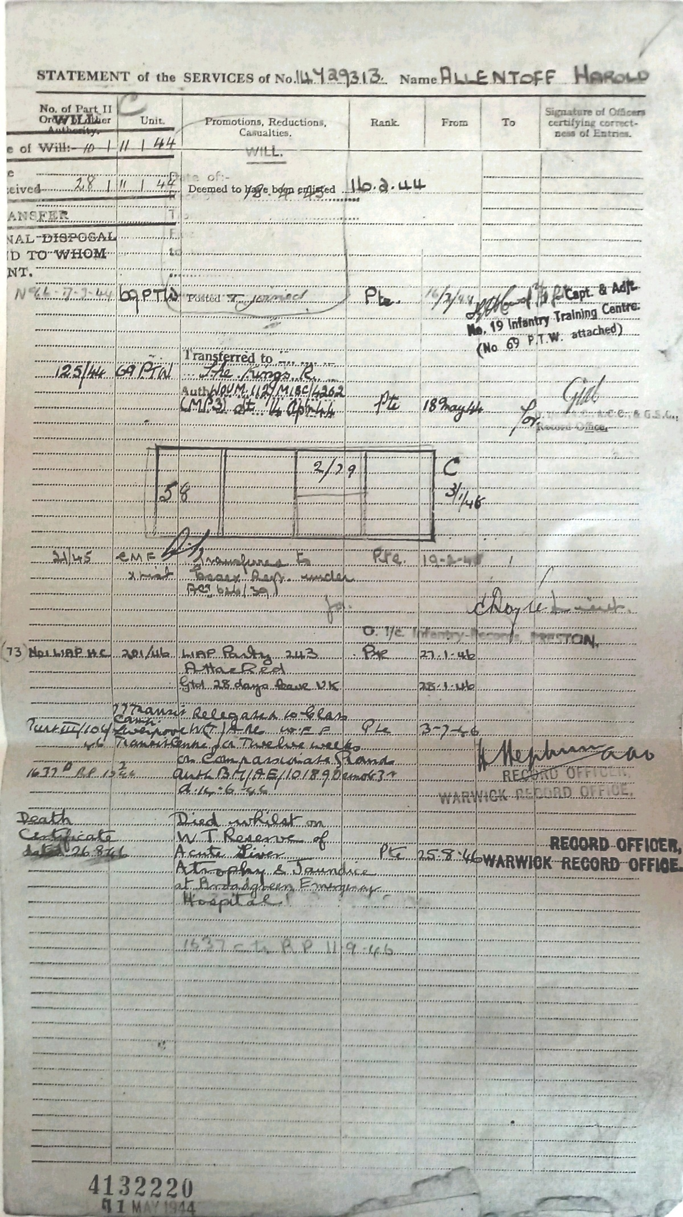
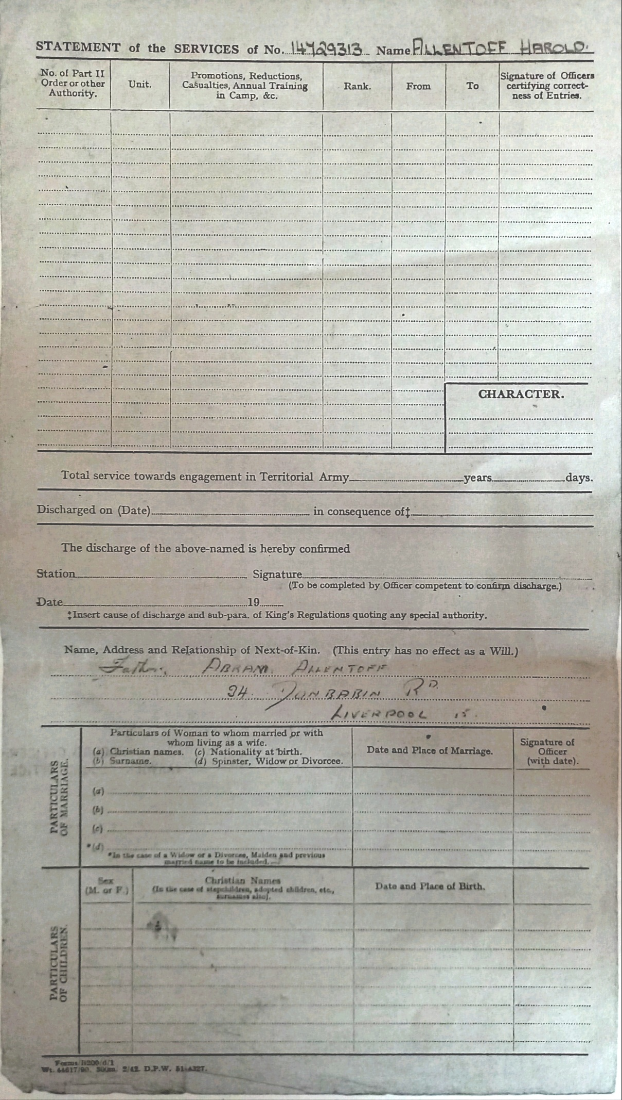
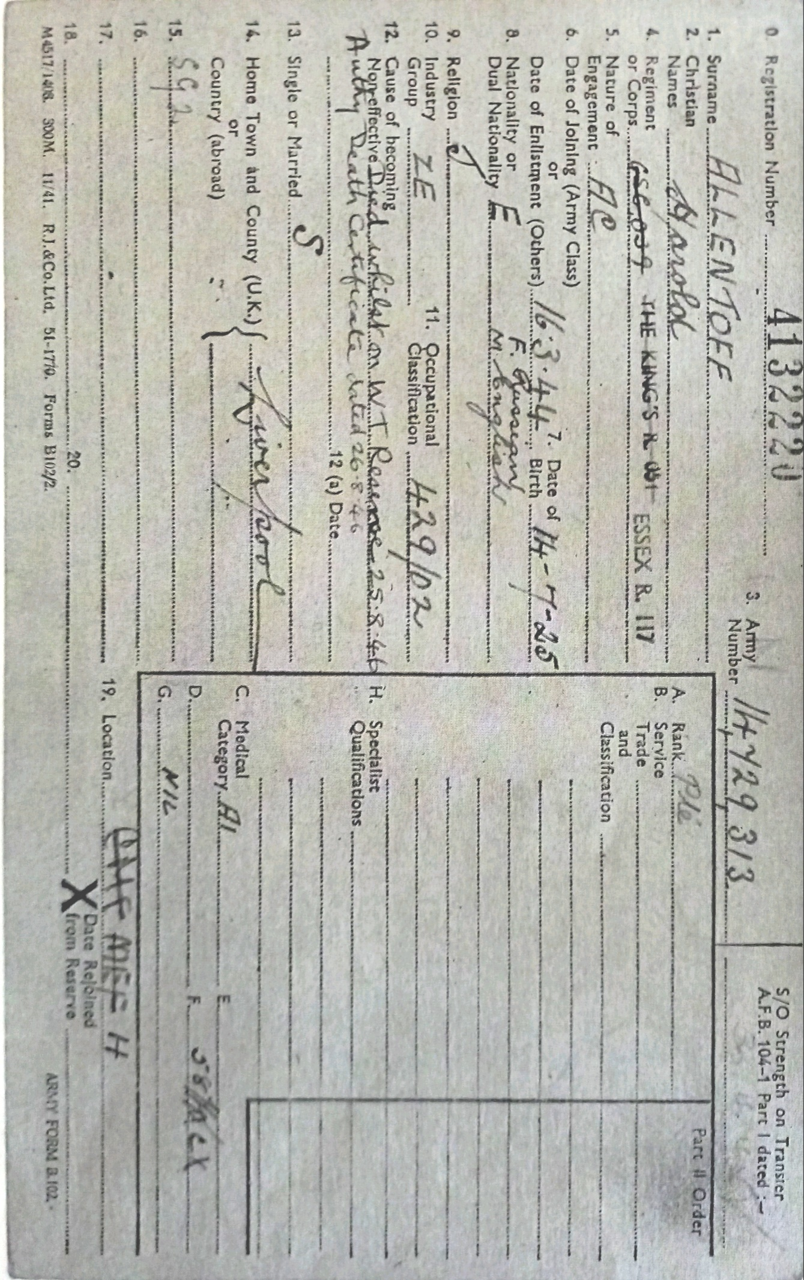
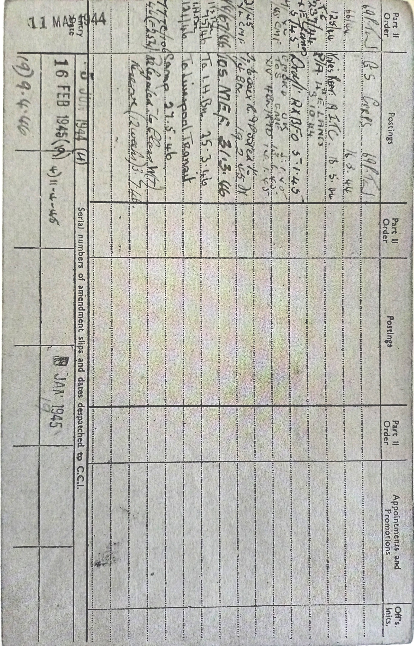
The family were members of the Childwall Synagogue, Dunbabin Road in Liverpool and Harold is commemorated on the Synagogue War Memorial.
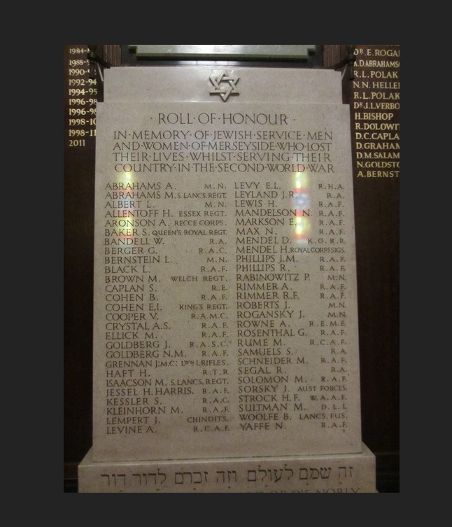
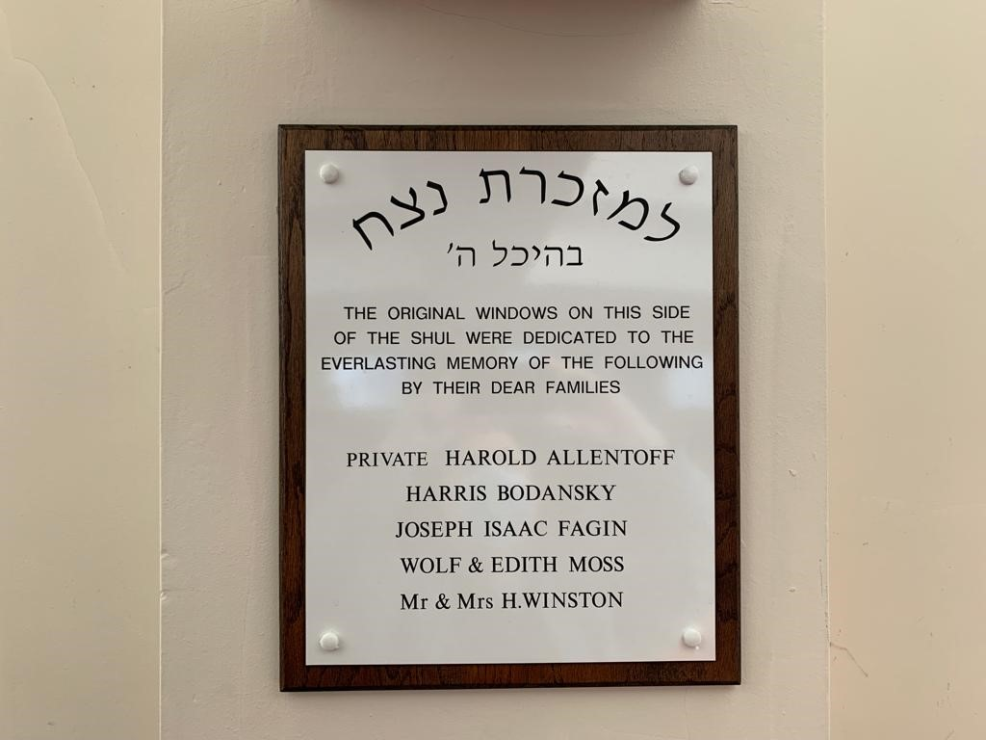
Harold’s family also dedicated windows in the Synagogue as stated on the above plaque.
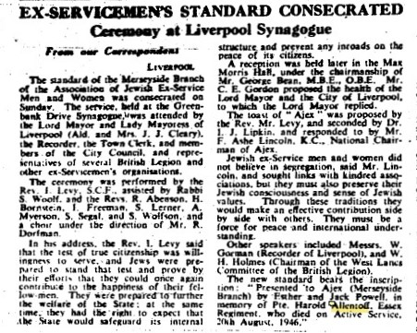
Jewish Chronicle 20 January 1950, reports that a new standard was consecrated at Liverpool Synagogue. The new standard bears the inscription: ‘Presented to Ajex (Merseyside Branch) by Esther and Jack Powell, in memory of Pte. Harold Allentoff, Essex Regiment, who died on Active Service, 26th August 1946’.
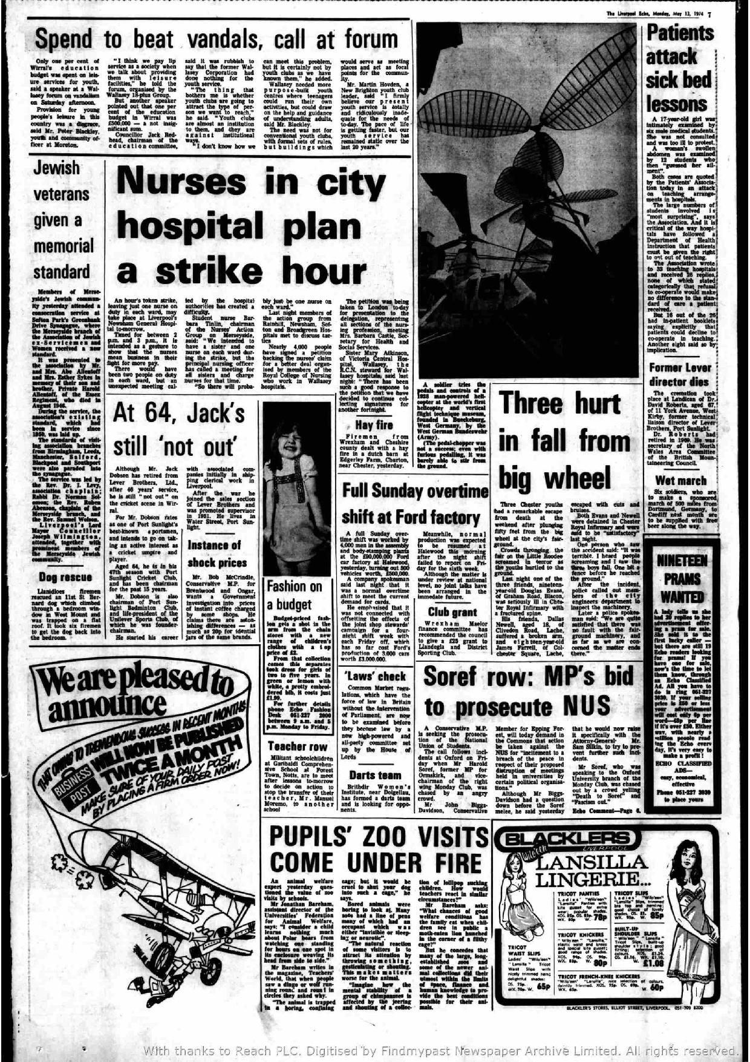
The Liverpool Echo, Monday May 13th, 1974
An article in the Liverpool Echo states the following: Members of Merseyside’s Jewish community yesterday attended a consecration service at Sefton Park’s Greenbank Drive Synagogue, where the Merseyside branch of the Association of Jewish ex0Servicemen and Women received a new standard.
It was presented to the association by Mr and Mrs Abe Allentoff and Mrs Esther Sykes in memory of their son and brother, Private Harold Allentoff of the Essex Regiment, who died in August 1946.
During the service the associations existing standard, which had been in service since 1950, was laid up.
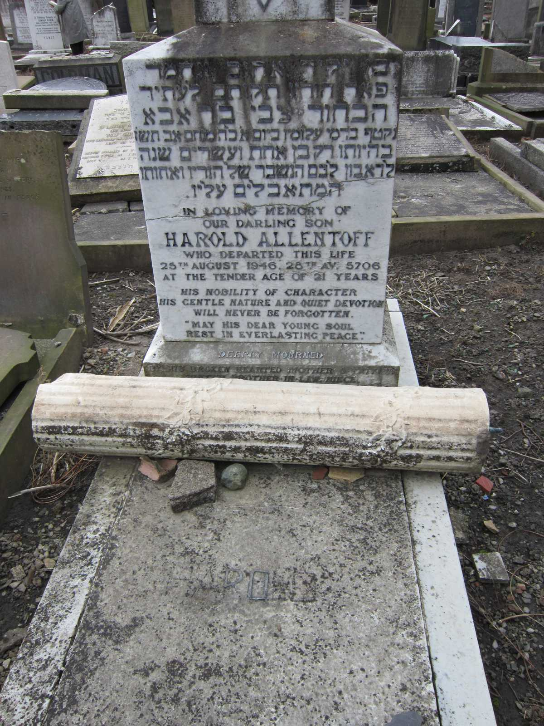
Harold is buried at Rice Lane Jewish Cemetery, Walton in Liverpool.

