Francis Gordon Hieger. Cross on headstone by default. CWGC advised Mother did not reply to letter.
Trooper Francis Gordon Hieger | War Casualty Details 2110714 | CWGC
Francis was born on 5 February 1920 at 20 Hampstead Road, London to Bernard Boris Hieger, a jeweller and watchmaker shopkeeper, and Florence Jessie Root.
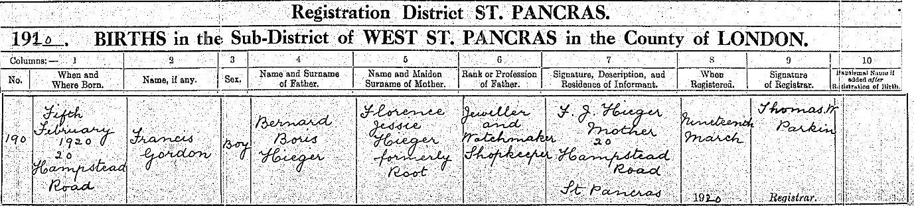
Francis was named after his grandfather Francis Ephraim Hieger who was born 1 August 1860 in Osieck, Poland and his grandmother was Chaje (Helena) who was born in 1861 in Siedlce, Poland. Francis and Helena had 7 children and the family fled from Siedlce just before the September Pogroms in 1906. The family arrived in Grimsby on the City of Bradford ship from Hamburg on 30 April 1906. Their children were Arnold Andre born 1881, Bernard born 1 Oct 1884, Dora born 1884, Charlotte born 1887, Simon Samuel born 18 Nov 1888, Maryon born 1892, Paula Patty born 17 Mar 1895, Rebecca born 31 Aug 1898 and Israel born 13 Jun 1901.
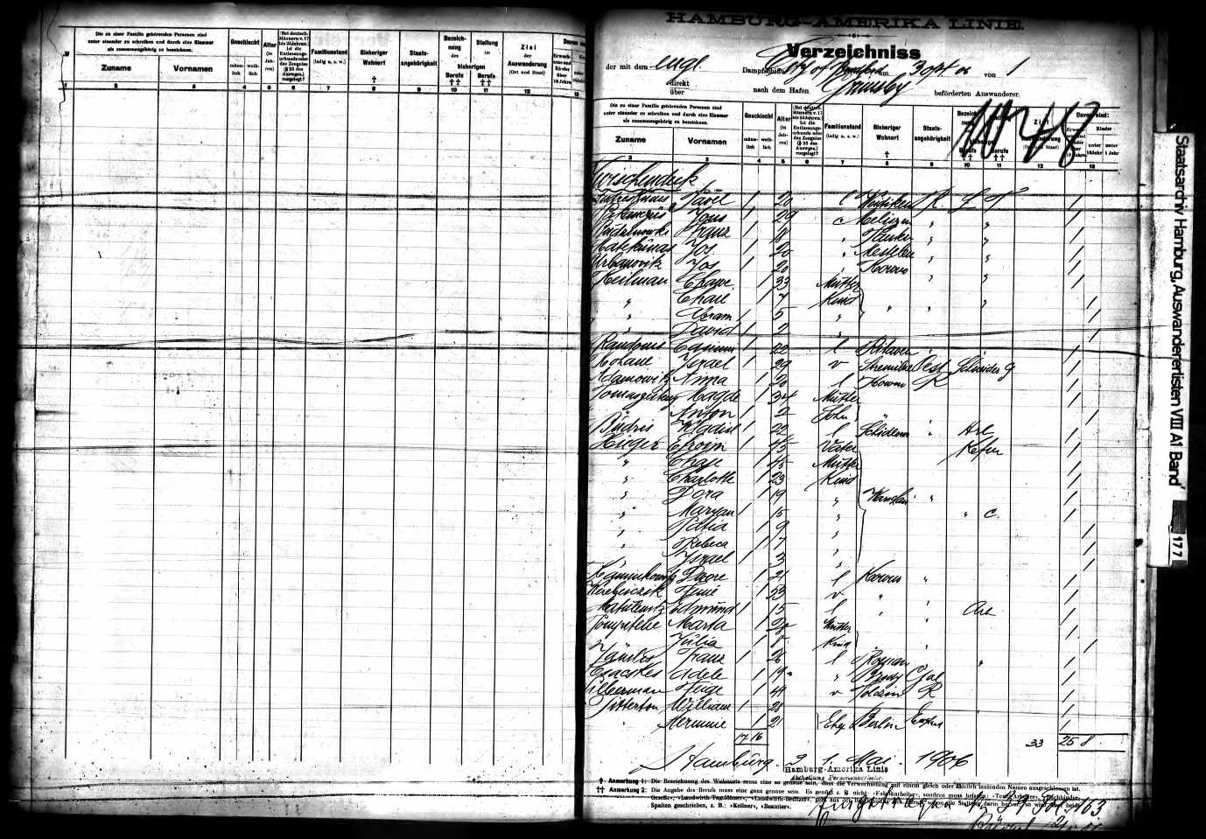
Passenger list for City of Bradford

In 1911 Census, Francis Ephraim was working as a Jeweller and watchmaker and living at 126 Lancaster Road, London.
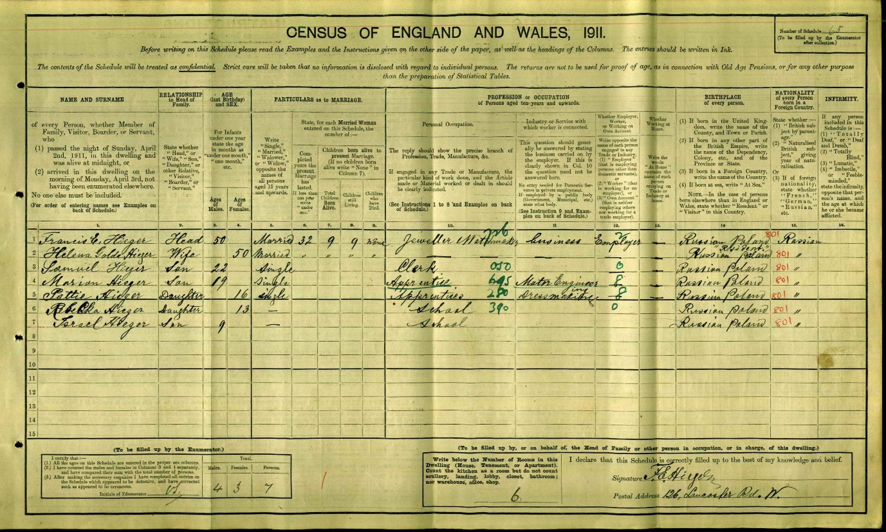
1911 Census At the address were Francis, Helena, Samuel, Maryon, Patty, Rebecca and Israel.
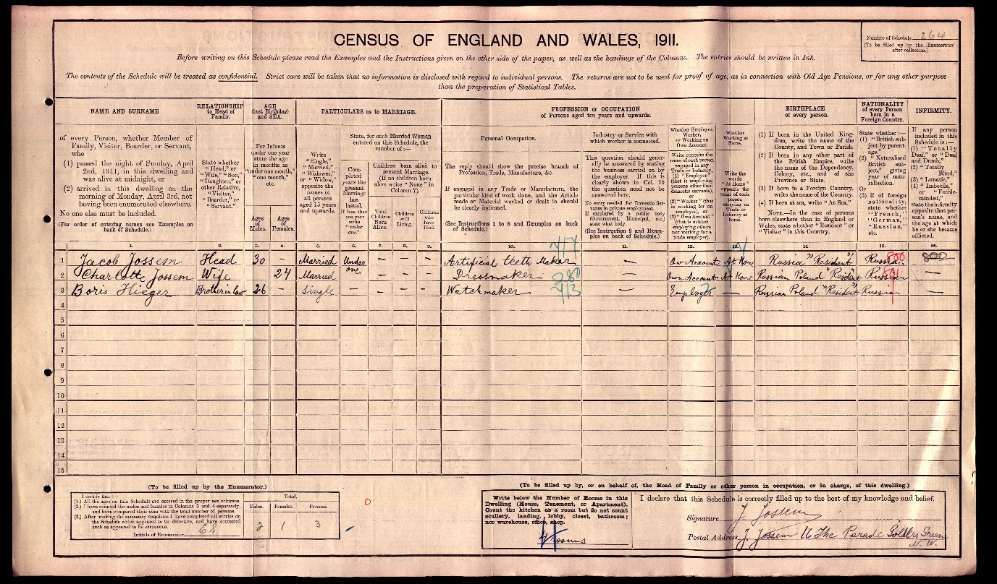
1911 Census Sister Charlotte married Jacob Jossem, a dentist, in 1911 and Bernard Boris is listed as living with them at 16 The Parade, Golders Green. Bernard Boris is working as a watchmaker.
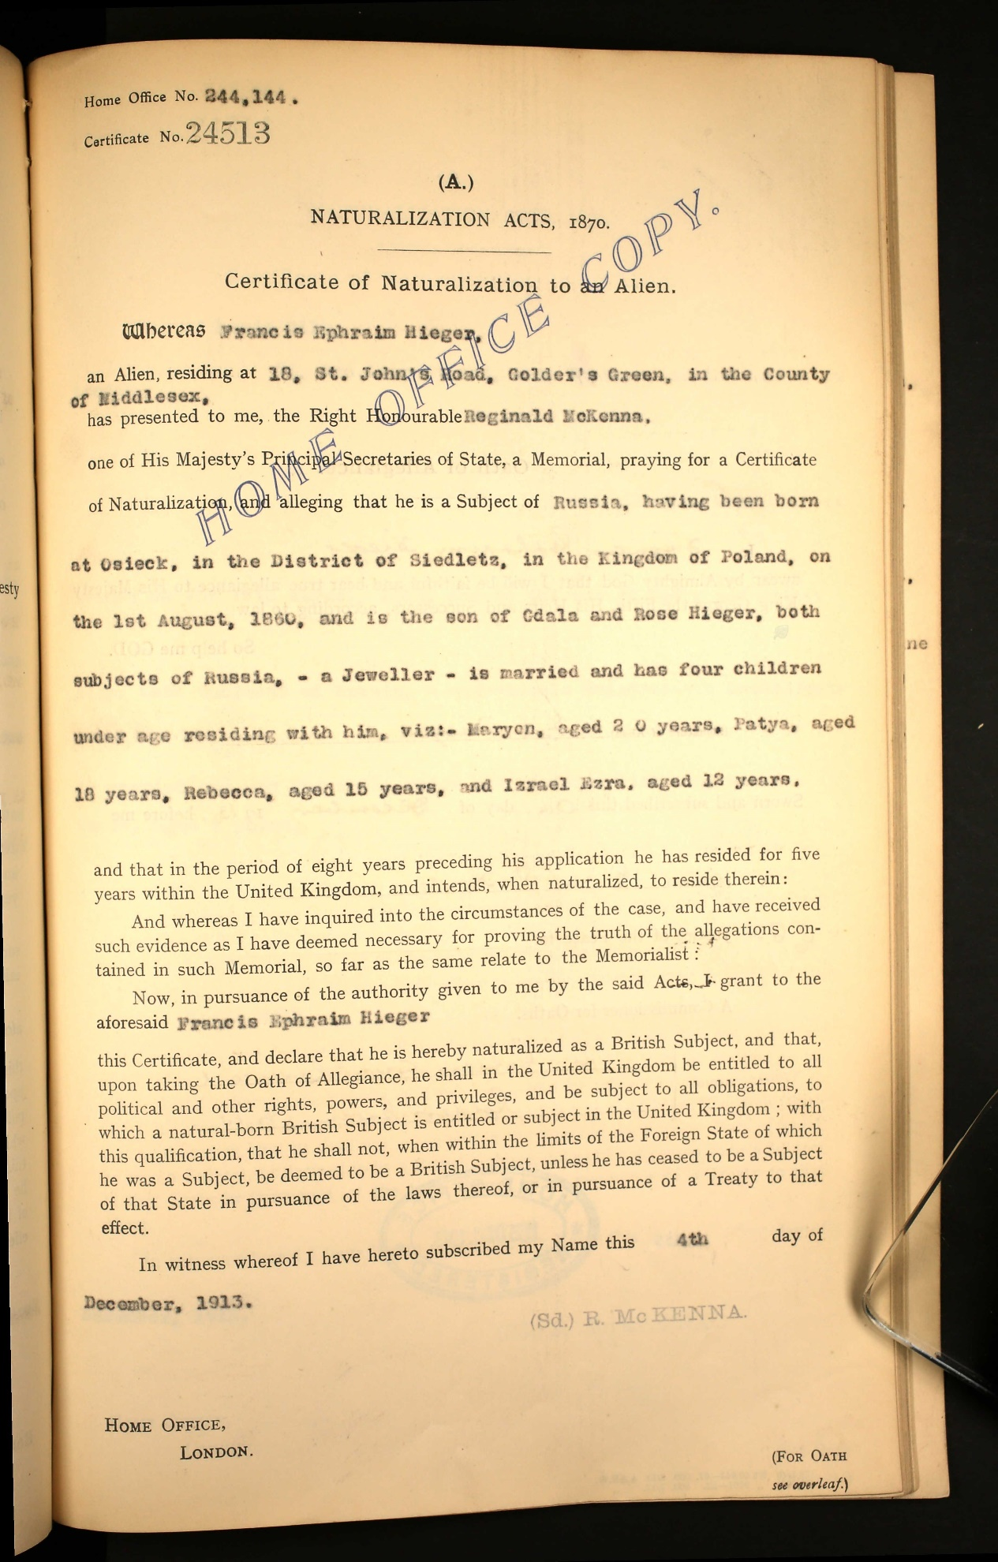
Francis became a naturalised British citizen on 4 December 1913

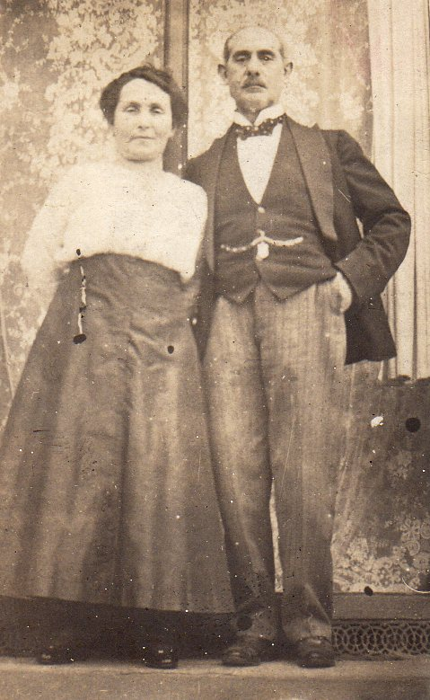Francis and Helena
Francis Ephraim died on 17 February 1920 and is buried at Willesden Jewish Cemetery. Helena died on 22 May 1938 and is buried next to Francis.
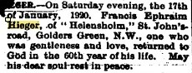Jewish Chronicle
Willesden | FRANCIS EPHRAIM |  |  | HIEGER |  | 19/01/1920 |  | MX |  | 3 |  | 3
Willesden |  | HELENA | HIEGER |  | 24/05/1938 |  | MX |  | 3 |  | 4

Francis and Helena’s children
Arnold Andre born 1881. He legally changed his surname in 1932 to Higuer and was an artist and an architect. He died in 1937 and is buried at Willesden Jewish Cemetery.

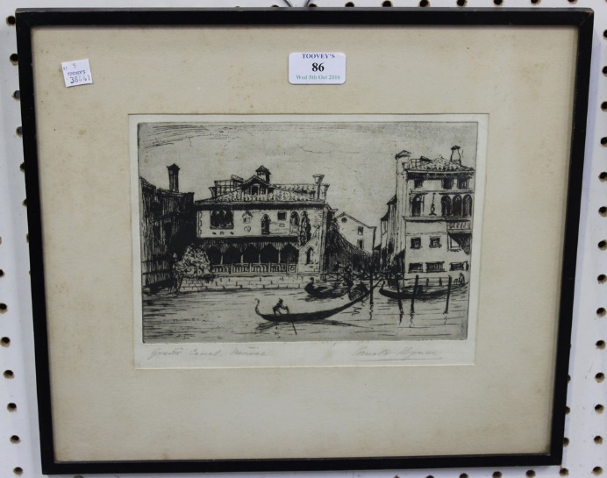 Arnold Higuer - 'Grand Canal, Venice', monochrome etching, signed in pencil, approx 18.5cm x 24.5cm, within an ebonized frame.
Dora born 1884, further details unknown.
Charlotte born 1887. Married Jacob Jossem, a dentist, in 1911. Jacob qualified in 1925. She died in 1930.
Simon Samuel born 18 Nov 1888. He was a portrait artist and a dealer in precious stones and works of art. He was unmarried and died in 1977.
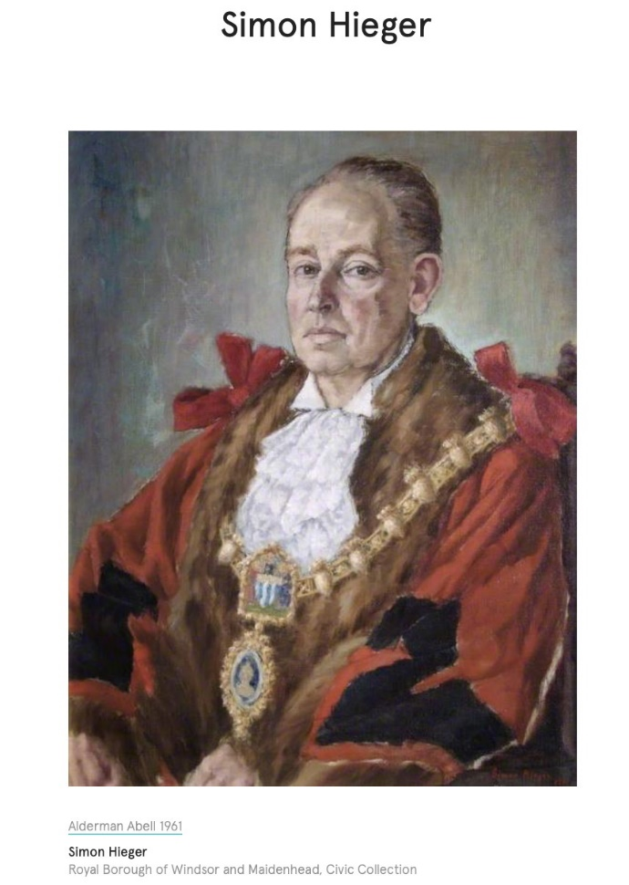
Maryon Hieger born 1892. He worked as a hat manufacturer and married a divorced woman Fanny (Frances) Goldberg, who had two children, Sybil and Stanley, in 1917. They had a son Francis Ephraim Joseph born in 1922. They divorced in 1935. He married Elsie Yolland in 1947 and died in 1953 in Hove, Sussex.
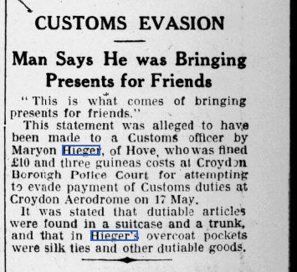Jewish Chronicle 15 July 1934
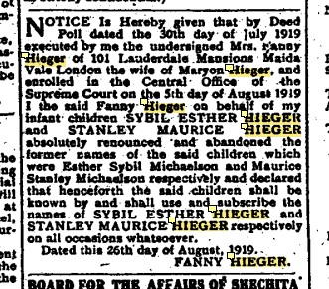Jewish Chronicle petition to change her children’s surnames.

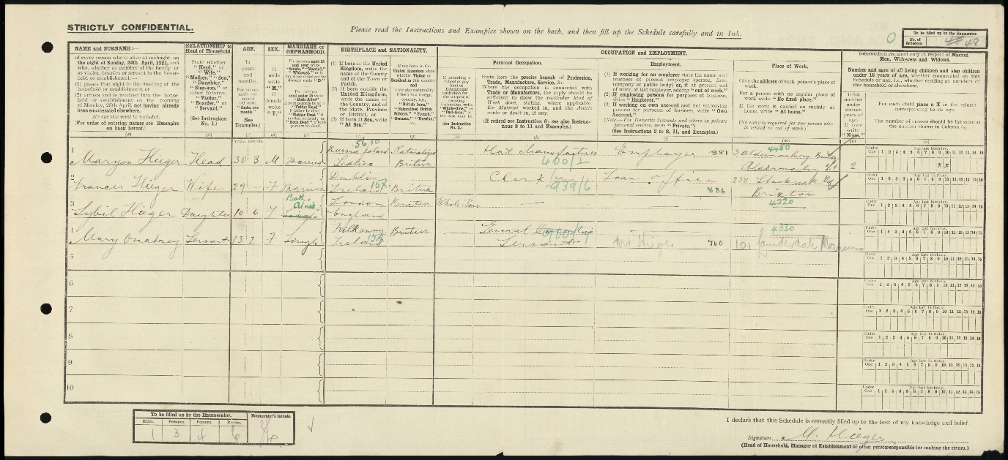
Maryon and Francis 1912 Census.
Patty Paula born 17 March 1895, unmarried dressmaker. Died Jan 1975 in Hendon.
Rebecca born 31 Aug 1898, unmarried. Died 1 Jan 1958.
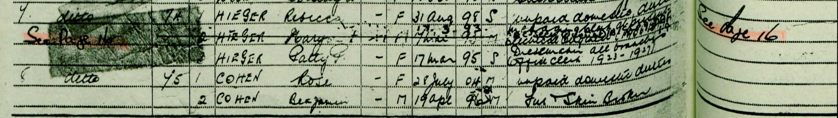
1939 Register. Rebecca, Maryon and Patty are living together at 7 Kingsley Close, Finchley
Israel born 13 June 1901. A biochemist who was nominated for a Nobel Prize for work on isolating chemical carcinogenic agents from tar. Izrael Hieger - Wikipedia He attended Christ’s College, Finchley, going on to study at Birkbeck and University College. He married Esther Bull in 1929 and divorced her in 1936. He then remarried to Lois Peirson and they had one daughter Barbara. He died in 1986 in Hendon.
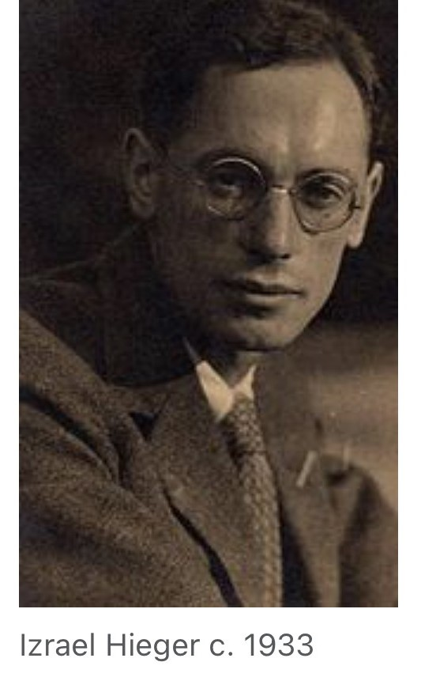
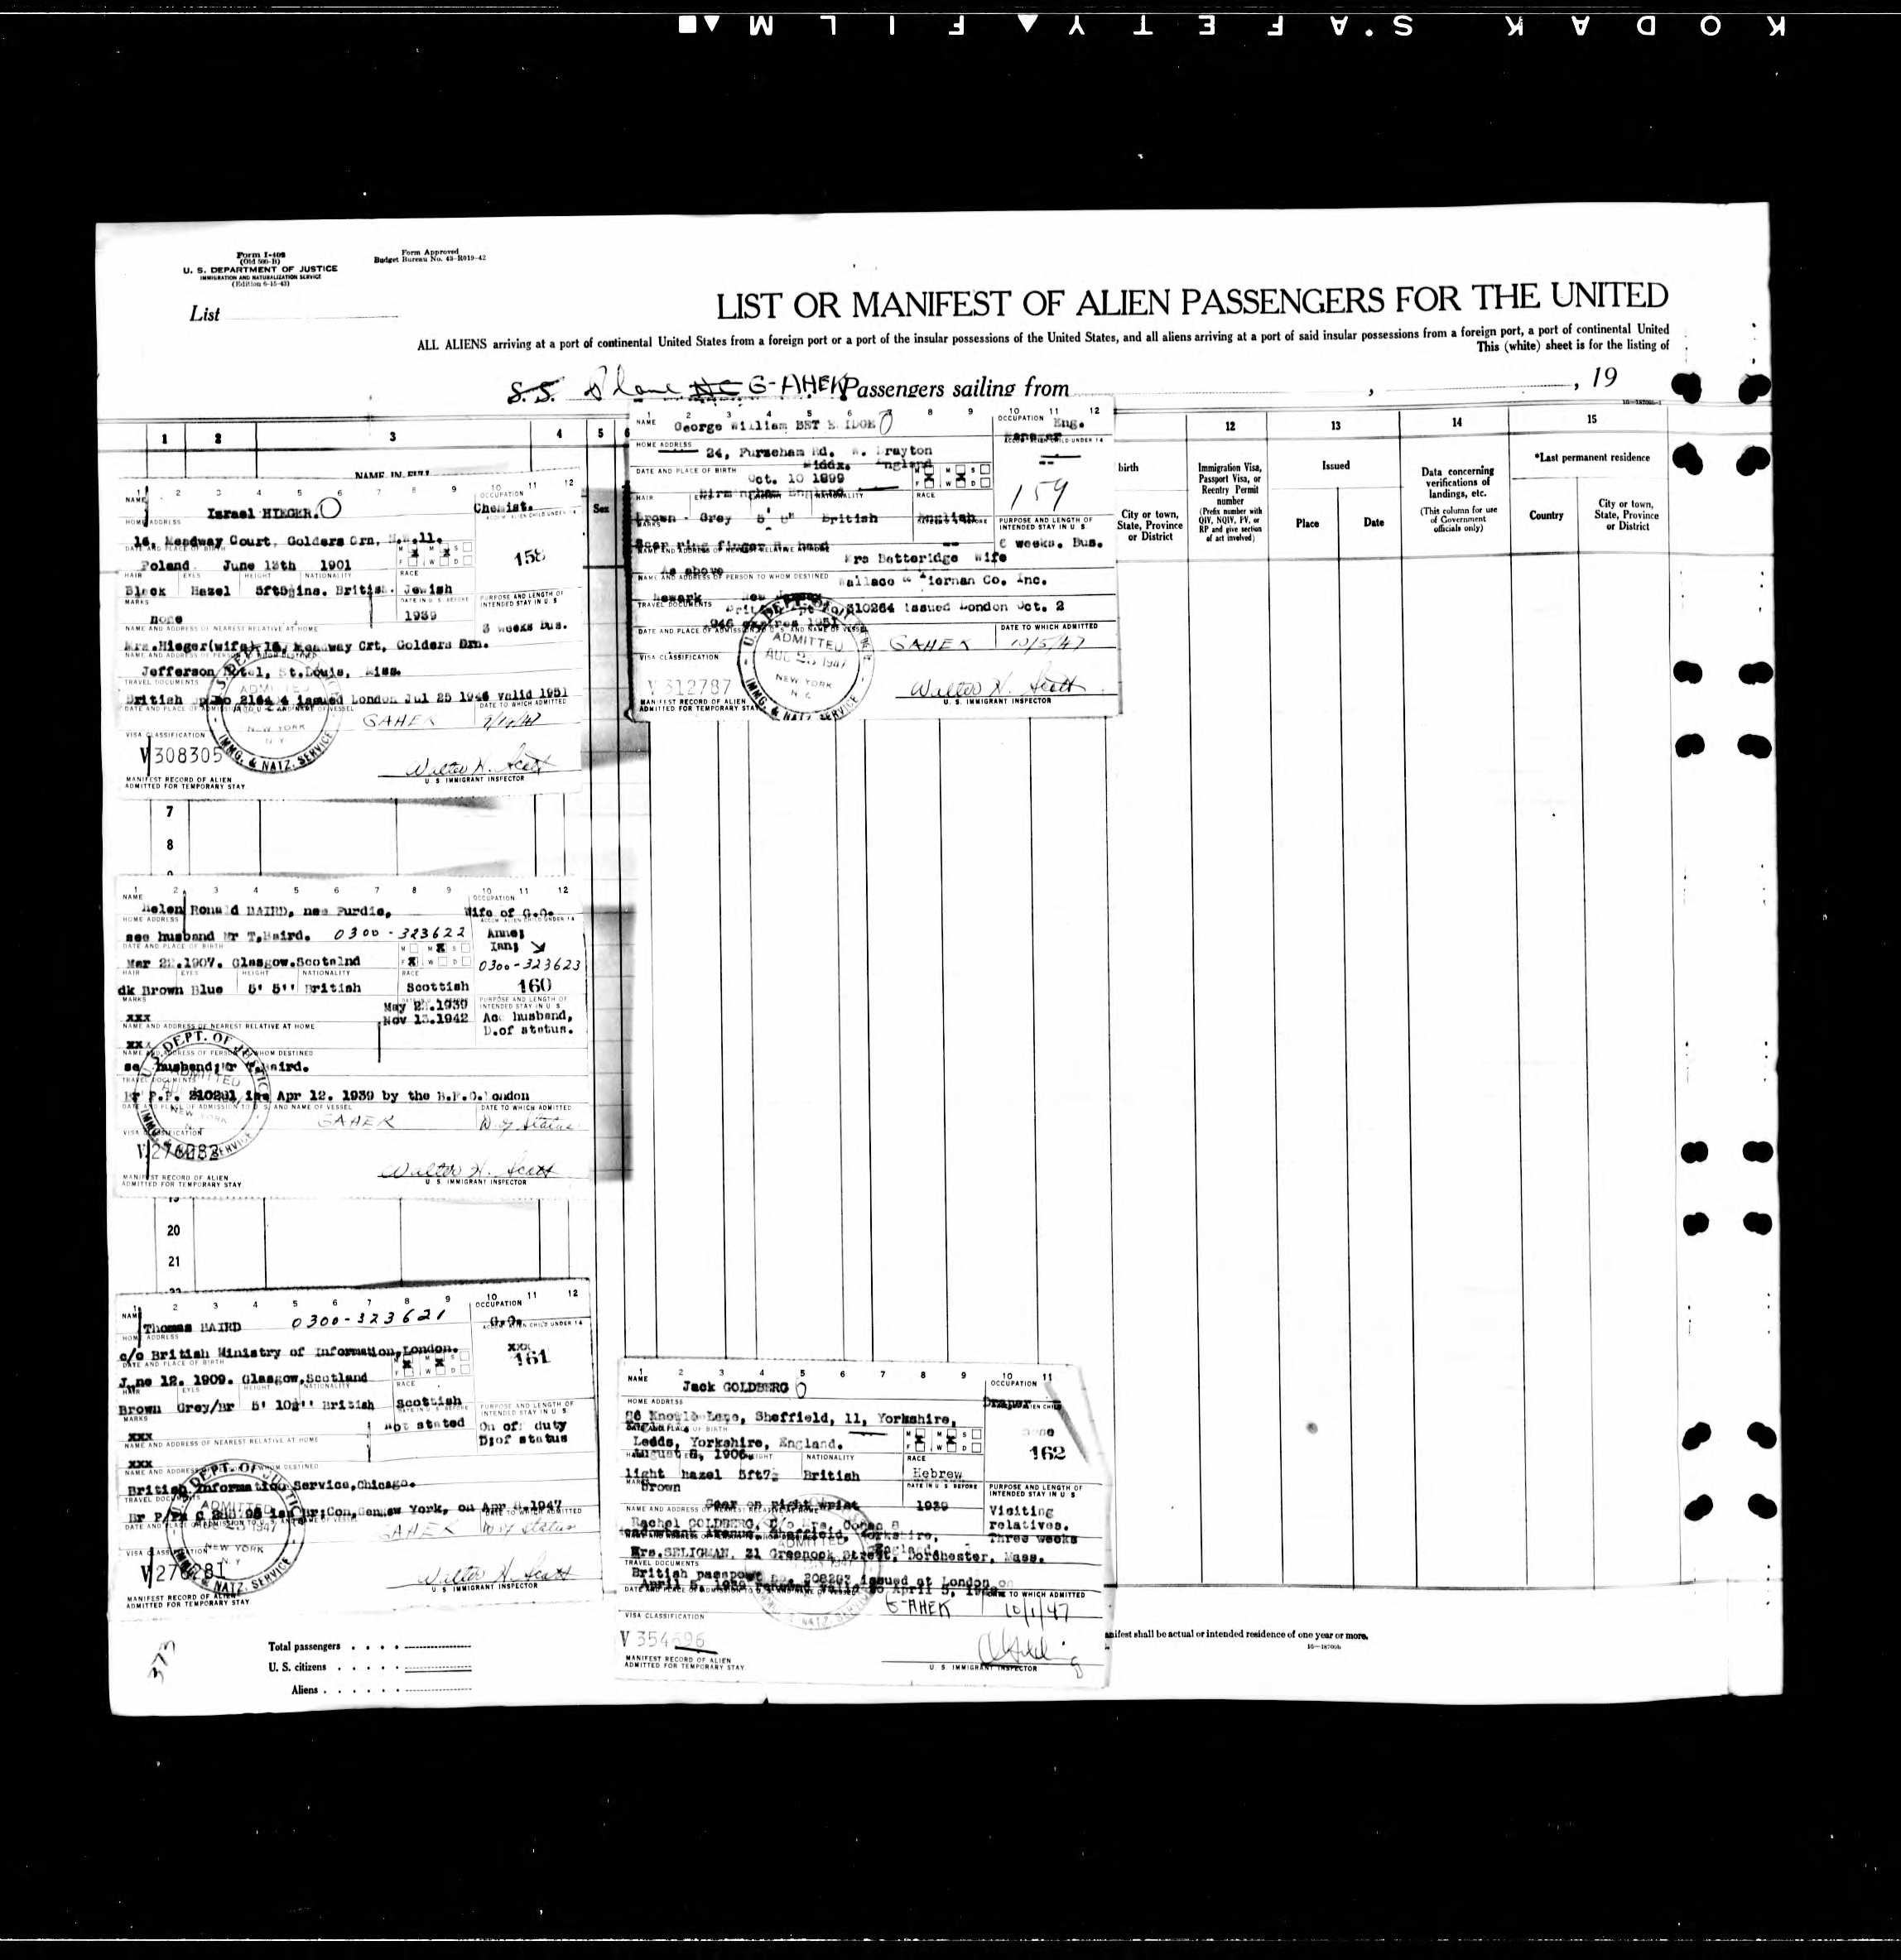
Israel travel document stating he was Jewish.
Bernard Boris, Francis’ father
Bernard Boris Hieger was born on 1 Oct 1894 in Poland. Bernard worked as a watchmaker at 176 Caledonian Road, London and in 1914 his shop was burgled.
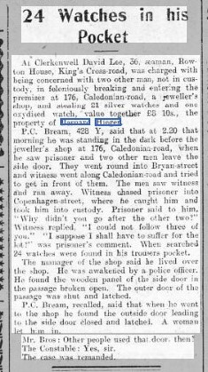Jewish Chronicle 13 March 1914
Bernard married Florence Jessie Root, born 8 Jan 1894 in Islington, in July 1917 in Pancras, London and their first son Francis Gordon was born on 5 February 1920 at 20 Hampstead Road, London, followed by Ronald Douglas Herrick in 1921.
In 1939, Bernard was living at 194 High Street, Heston and was listed as married and a company director.
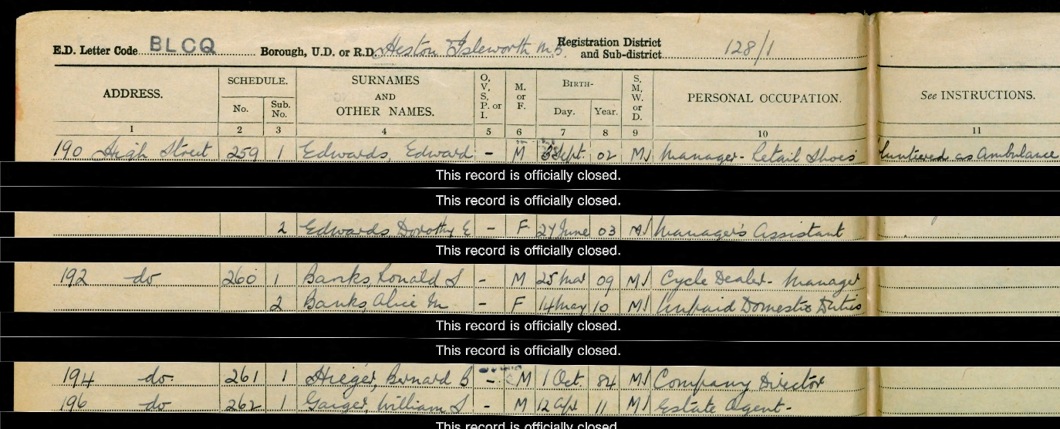
1939 Register
Florence and Ronald were living at 40 Hendon Way, Hendon.
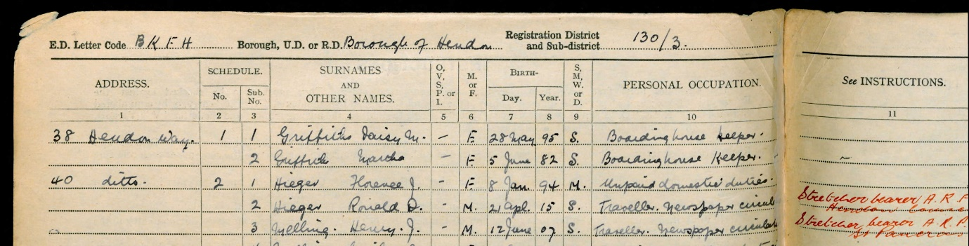
Francis enlisted into the 3 County of London Yeomanry, 22 Armoured Brigade, Royal Armoured Corps. His records state that he died as a result of an accident. His brother also served in the Army in the Royal Regiment of Artillery and was a 2nd Lieutenant, Service number 232320.
Bernard Boris was the Treasurer of the Hounslow and District Synagogue and just before his death on 30 March 1946 he attended the annual meeting in Jan 1946.
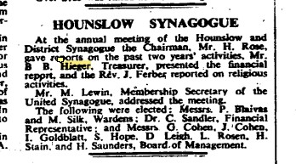Jewish Chronicle Jan 1946

